Oxygen Plasma Operating Procedure 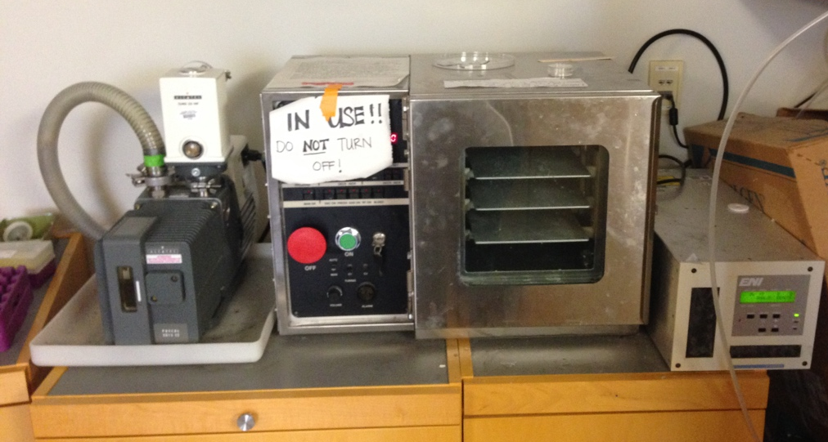
- Turn on Vacuum pump (toggle switch on side closest to the plasma chamber)
- Turn on O₂ plasma chamber controls, put sign down so other people know it’s on.
- Wait 1 hour for machine to warm up.
- Load substrates in petri dishes with covers off (some debate about this- some people say leave them on because it will still work, other protocols say take the covers off for better bombardment)
- Open both nitrogen (orange valve on wall across from vacuum) and O₂ tank (turn top valve counterclockwise to open) fully.
Sulfur Hexaflouride gas is Gas 1, Oxygen is gas 2 on the right side of the control panel.
- DO NOT CHANGE PROGRAMS 1 or 9 on the chamber controls.
  - The following program settings can be changed:
    - for Gas: SCCM flow rate can range 0-100
    - Left side controls: Pressure, Power and time
  - DO NOT CHANGE ANY OTHER SETTINGS

- To check setting, use Program button to cycle through program numbers, L Disp to cycle through settings for Pressure, Power, Time. You shouldn’t need to change anything else on the left side of the control panel. To change the setting, press Set button then either Decr or Incr. Decr is the button to decrease (lower) the setting and Incr is the button to increase (raise) the setting number. Check that the right side has the correct gas and flow rate (SCCM number). This can be increased or decreased using the right side increase or decrease buttons.
- Make sure you are using the correct gas. Plasma and descum use only Gas 2 (oxygen). SU-8 and other materials etching may use SF₆ (Gas1) depending on the protocol.
- Make sure the door is closed and latched.
- The countdown timer starts when the RF generator begins, and plasma has struck.
- Wait for the cycle to begin bleeding. You will hear a high pitched whistling of air when it’s bleeding. Press stop after 5 seconds. Open the door slowly. If the door doesn’t open, the chamber is still under vacuum. Rerun the cycle (or a shorter 10 second one) and wait until the air has started bleeding again. Press stop after 5 seconds. Try to open the door slowly. If the door still won’t open, find one of the senior students to help you.
- Close the O₂ tank by turning the valve clockwise until it is fully closed. Shut off the Air (orange valve on wall) and leave machine on with sign down. If it is the end of the day (6:00 pm) turn off the chamber then the vacuum pump. Put sign up on top of machine.

