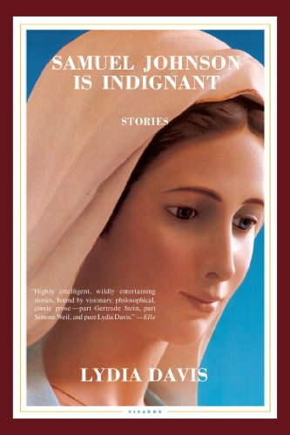
Betrayal
Lydia Davis is perhaps the greatest living English-language writer of “flash fiction”: short stories that push the limit of how “short” a story can be, sometimes down to just a handful of words. “Betrayal” narrates the progression of an unnamed woman’s fantasies in just five long, flowing sentences, provoking questions about desire, intimacy, and guilt. Davis’ dreamlike prose captures how the woman’s increasingly mundane fantasies might become “indistinguishable from the reality of her everyday life” while still feeling different – secret and shameful.

Questions
- What makes the woman’s non-sexual or non-romantic fantasies still feel like “a sort of betrayal”? Why does the story claim that “perhaps they had to be, to be any comfort and strength”?
- Why does the woman eventually wind up fantasizing about the kinds of friendly relationships she already enjoys? Does fantasy always have to be a wish for something you don’t have? If so, what is it that she craves?
- Does it matter that this story is about a woman in a relationship with a man, fantasizing about men? Would it feel different if the subject were a straight man? How about a same-sex relationship or same-sex fantasies? If so, why might that be?
- This story was included in “The Best American Poetry” 1999. Why would someone consider this poetry? Would you read this differently if you read it as a poem?

References
Allred, N. (2016). R4R discussion blurb for facilitators. (R4R LibGuide)
Davis, L. (2001). Betrayal. In Samuel Johnson is indignant: stories. Brooklyn, N.Y: McSweeney’s Books.

Notes on discussion
The discussion questions provided here are suggestions. Groups should not feel required to work in order or to address all of them. Instead, these questions are meant to solicit observations that can lead to connections. Those connections can be to personal experience; participants should feel free to share if their experiences can help the group get some insight into the topic at hand, since after all that’s the point of the exercise. Don’t feel compelled to jump to the “point” or “lesson” of the text right away. Philosophically speaking, the text doesn’t contain the “lesson”; if anything, the discussion does. Give that discussion time to develop, and make sure participants respond to or build on each other’s points rather than jumping around. If you’re having trouble getting the ball rolling or finding something insightful to say, try focusing on a particularly complex passage and figuring out what makes it hard to follow or makes sense of. Don’t be afraid of asking questions you don’t know the answer to; articulating a question can be just as valuable to a discussion as providing an answer.

About the author
Lydia Davis (born July 15, 1947) is an American writer noted for literary works of extreme brevity (commonly called "flash fiction"). Davis is also a short story writer, novelist, essayist, and translator from French and other languages, and has produced several new translations of French literary classics, including Swann’s Way by Marcel Proust and Madame Bovary by Gustave Flaubert. [Wikipedia]

Short story collections by the same author

The Thirteenth Woman and Other Stories. Living Hand, 1976.
Story and Other Stories. The Figures, 1985.
Break It Down. Farrar, Straus & Giroux, 1986.
Almost No Memory. Farrar, Straus & Giroux, 1997.
Samuel Johnson Is Indignant. McSweeney’s, 2001.
Varieties of Disturbance. Farrar, Straus & Giroux, 2007.
The Collected Stories of Lydia Davis. Farrar, Straus & Giroux, 2009.
Can’t and Won’t: Stories. Farrar, Straus & Giroux, 2014.

