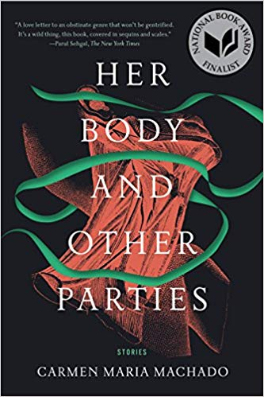
Synopsis
Carmen Maria Machado offers a haunting, first-person account of bariatric (i.e. weight loss) surgery in a series of vignettes. Along the way we get a snapshot of three generations of women’s relationships to food and to each other: the narrator’s mother, who preached and practiced rigorous self-denial; her sisters, who had the surgery themselves and vouch for it in whispers like a guilty pleasure; and her daughter, concerned about complications and hurt by her mother’s choice in ways she struggles to explain.

Questions
- Think about the mother-daughter relationships in this story. How does the narrator’s mother shape the narrator’s attitudes and choices? Why does the narrator’s daughter react so strongly against the surgery?
- Where do we see pleasure in this story? Where do we see shame? How can we tell?
- What do you make of the oysters that appear in the story? What do they mean to the narrator, and what can we tell about her from this? How about the grapefruit she eats after the surgery?
- What do you make of the three sisters’ responses to the narrator’s question about feeling a presence in the house after the surgery? Why does Machado write these lines that most people wouldn’t say in everyday life as “dialogue”?
- What is the “thing” that appears late in the story? What is the narrator’s relationship to it? Why is it described in the way that it is?

References
Allred, N. (2016). R4R discussion blurb for facilitators. (R4R LibGuide)
Machado, C. M. (2017). Eight bites. In Her body and other parties. Minneapolis, MN: Graywolf Press.

Notes on discussion
The discussion questions provided here are suggestions. Groups should not feel required to work in order or to address all of them. Instead, these questions are meant to solicit observations that can lead to connections. Those connections can be to personal experience; participants should feel free to share if their experiences can help the group get some insight into the topic at hand, since after all that’s the point of the exercise. Don’t feel compelled to jump to the “point” or “lesson” of the text right away. Philosophically speaking, the text doesn’t contain the “lesson”; if anything, the discussion does. Give that discussion time to develop, and make sure participants respond to or build on each other’s points rather than jumping around. If you’re having trouble getting the ball rolling or finding something insightful to say, try focusing on a particularly complex passage and figuring out what makes it hard to follow or makes sense of. Don’t be afraid of asking questions you don’t know the answer to; articulating a question can be just as valuable to a discussion as providing an answer.

About the author
Carmen Maria Machado is the author of the memoir In the Dream House and the short story collection Her Body and Other Parties. She has been a finalist for the National Book Award and the winner of the Bard Fiction Prize, the Lambda Literary Award for Lesbian Fiction, the Brooklyn Public Library Literature Prize, the Shirley Jackson Award, and the National Book Critics Circle's John Leonard Prize. In 2018, the New York Times listed Her Body and Other Parties as a member of "The New Vanguard," one of "15 remarkable books by women that are shaping the way we read and write fiction in the 21st century." [Author’s site]
Short story collections by the same author
Her Body and Other Parties. Graywolf, 2017.

