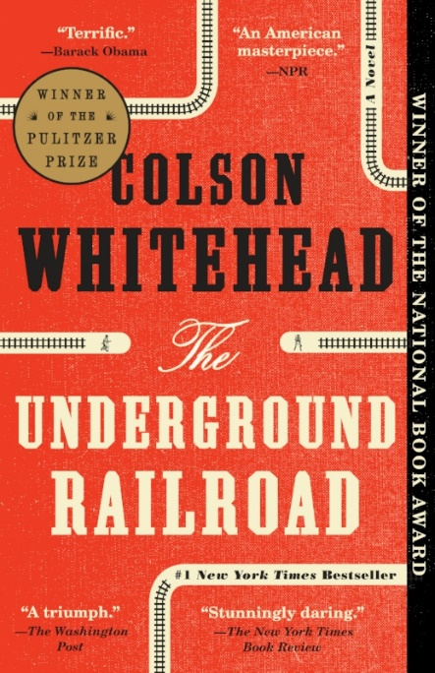
Colson Whitehead: Down in front
Relax, it’s just a movie – or is it? In this short story originally published in Granta, acclaimed author Colson Whitehead narrates a date at a movie theater, where what happens on screen and in the audience quickly turns into a roving metaphor for love, life, and the things we “project” onto events and ourselves. If you know Whitehead for his harrowing masterpiece The Underground Railroad, come here to experience his playful, cynical wit – and stay for the subtle musings about conventional stories and how we cling to them, even as we roll our eyes.

Questions
- Whitehead describes finding your seat in a movie theater as if giving directions to the reader: “Step on toes, suck in gut, make yourself flat as a movie screen.” Why the simile “flat as a movie screen” – what might that mean in the context of a story about dating? Why phrase it as a direction?
- Why does Whitehead use a movie as a metaphor for a relationship? What does this suggest about relationships (or about movies)? Find lines in the story to support your view!
- What’s the tone of this story? What’s the attitude of this story towards movies? Towards dating? Towards people?
- What does the ending mean, about looking “for my name in the credits”
- How is a short story like a movie, or a relationship? How is it different? Is this story (“Down in Front”) itself the kind of story that it describes, or not?

References
Whitehead, Colson (2004). Down in front. Granta 84 (2004).

Notes on discussion
The discussion questions provided here are suggestions. Groups should not feel required to work in order or to address all of them. Instead, these questions are meant to solicit observations that can lead to connections. Those connections can be to personal experience; participants should feel free to share if their experiences can help the group get some insight into the topic at hand, since after all that’s the point of the exercise. Don’t feel compelled to jump to the “point” or “lesson” of the text right away. Philosophically speaking, the text doesn’t contain the “lesson”; if anything, the discussion does. Give that discussion time to develop, and make sure participants respond to or build on each other’s points rather than jumping around. If you’re having trouble getting the ball rolling or finding something insightful to say, try focusing on a particularly complex passage and figuring out what makes it hard to follow or makes sense of. Don’t be afraid of asking questions you don’t know the answer to; articulating a question can be just as valuable to a discussion as providing an answer.

About the author
Colson Whitehead (1969-) is an American novelist. He is the author of six novels, including his debut work, the 1999 novel The Intuitionist, and The Underground Railroad (2016), for which he won the 2016 National Book Award for Fiction and the 2017 Pulitzer Prize for Fiction. He has also published two books of non-fiction. In 2002, he received a MacArthur Fellowship ("Genius Grant"). [Wikipedia]
Works by the same author
The Intuitionist (Anchor, 1999)
John Henry Days (Doubleday, 2001)
The Colossus of New York (Doubleday, 2003)
Apex Hides the Hurt (Doubleday, 2006)
Sag Harbor (Doubleday, 2009)
Zone One (Doubleday, 2011)
The Noble Hustle: Poker, Beef Jerky, and Death (Doubleday, 2014)
The Underground Railroad (Doubleday, 2016)
The Nickel Boys (Doubleday, 2019)

