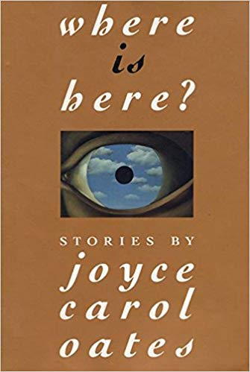
Synopsis
A couple opens their home to a stranger who says he lived there as a child. Joyce Carol Oates narrates the couple’s growing unease with the stranger’s visit in a restrained, matter-of-fact style, capturing the anger and dread lying just behind the appearance of middle-class respectability. Part comedy of manners, part bourgeois tragedy, “Where Is Here?” poses the question of what makes a house into a home in ways that no greeting card or throw pillow would dare!

Questions

- What might be “enormously exciting yet intimidating” about returning to your childhood house where a new family now lives? What might be uncomfortable about watching a stranger who once lived in your house explore it?

- The characters in this story are never named — they are referred to as “the mother,” “the father,” “the stranger,” and “the son.” Why might Oates choose to refer to them this way? What would feel different about the story if the characters were called by first names, or last names, or even “Mother” and “Father” as opposed to “the mother” and “the father”?

- What does the stranger’s behavior suggest about his family life? What do the mother’s and the father’s behavior suggest about theirs?

- The basement, Oates writes, “was not a part of their house the father and mother would have been comfortable showing to a stranger.” The basement is also the last thing the stranger asks to see as the father escorts him out. What significance might the basement have? Do all families have a “basement” that they would rather not show?

- What do you make of the stranger’s riddles, and the father’s reaction to them? Follow the stranger’s instructions to the son for the “mathematical riddle” of infinite triangles within a square — how might this image relate to the story as a whole?

References
Allred, N. (2016). R4R discussion blurb for facilitators. (R4R LibGuide)
Oates, Joyce Carol. “Where is Here?” In Where is Here? Stories by Joyce Carol Oates. New York: Ecco, 1992.

Notes on discussion
The discussion questions provided here are suggestions. Groups should not feel required to work in order or to address all of them. Instead, these questions are meant to solicit observations that can lead to connections. Those connections can be to personal experience; participants should feel free to share if their experiences can help the group get some insight into the topic at hand, since after all that’s the point of the exercise. Don’t feel compelled to jump to the “point” or “lesson” of the text right away. Philosophically speaking, the text doesn’t contain the “lesson”; if anything, the discussion does. Give that discussion time to develop, and make sure participants respond to or build on each other’s points rather than jumping around. If you’re having trouble getting the ball rolling or finding something insightful to say, try focusing on a particularly complex passage and figuring out what makes it hard to follow or makes sense of. Don’t be afraid of asking questions you don’t know the answer to; articulating a question can be just as valuable to a discussion as providing an answer.

About the author
(born June 16, 1938) is an American writer. Oates published her first book in 1963 and has since published 58 novels, as well as a number of plays and novellas, and many volumes of short stories, poetry, and nonfiction. She has won many awards for her writing, including the National Book Award for her novel them (1969), two O. Henry Awards, the National Humanities Medal, and the Jerusalem Prize (2019). Her novels Black Water (1992), What I Lived For (1994), and Blonde (2000) and short story collections The Wheel of Love and Other Stories (1970) and Lovely, Dark, Deep: Stories (2014) were each finalists for the Pulitzer Prize. [Wikipedia]
Works by the same author
them (1969)
The Wheel of Love and Other Stories (1970)
Marriages and Infidelities (1972)
Where are You Going, Where Have You Been? (1974)
You Must Remember This (1987)
American Appetites (1989)
Black Water (1992)
What I Lived For (1994)
Zombie (1996)
We Were the Mulvaneys (1996)
Blonde (2000)
The Gravedigger’s Daughter (2007)
The Corn Maiden and Other Nightmares (2012)
Black Dahlia and White Rose: Stories (2013)
Lovely, Dark, Deep: Stories (2014)

