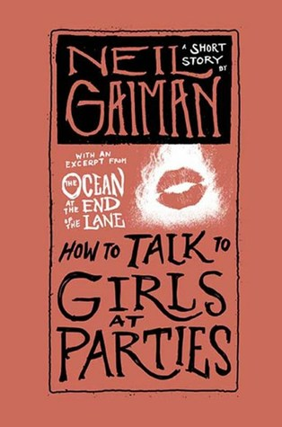
Synopsis
Thirty years after a party that changed his life, Enn reflects on the night, the girls he met, and the circumstances that made him and his friend run as far from those girls as they could. Nominated for the 2007 Hugo award, Neil Gaiman’s short story makes readers’ questions the circumstance of Enn and Vic’s night and what they truly encountered.

Questions
- Within the first paragraph, Enn makes it clear that he is reflecting on this night thirty years later. Considering he is relaying all of this from a memory, can we call him a reliable narrator? Should we trust his story?
- If we heard this memory from Vic’s perspective what difference do you think we would see?
- When it comes to talking to girls at parties Vic’s main advice is “You just have to talk to them”. But we rarely see Enn follow this advice, in fact it seems Enn is so focused on the girls physically that he is rarely listening as well. What do you think about Enn’s interactions with the different girls? Is there a difference between listening and hearing?
- Reflect on the three girls Enn interacts with: Stella (n. A star-shaped projection on the surface of a coralline; also, a star-shaped sponge-spicule), Wain (n. a large open vehicle), the unnamed gap-toothed girl, and Triolet (n. a stanza of eight lines, constructed on two rhymes, in which the first line is repeated as the fourth and seventh and the second as the eight). Did Gaiman name or not name these girls with a purpose in mind? What do these name say about their purpose either in the world or within the story? Definitions from the Oxford English Dictionary.
- After the boys run out of the party Vic says “You know . . . I think there's a thing. When you've gone as far as you dare. And if you go any further, you wouldn't be you anymore? You'd be the person who'd done that? The places you just can't go. . . . I think that happened to me tonight." What do you think Vic means by this? What could have happened to him while he was with Stella? Or what do you think he saw?

References
Allred, N. (2016). R4R discussion blurb for facilitators. (R4R LibGuide)
Gaiman, N. (2007). How to talk to girls at parties. http://www.neilgaiman.com/Cool_Stuff/Short_Stories/How_To_Talk_To_Girls_At_Parties/How_To_Talk_To_Girls_At_Parties_(Text)

Notes on discussion
The discussion questions provided here are suggestions. Groups should not feel required to work in order or to address all of them. Instead, these questions are meant to solicit observations that can lead to connections. Those connections can be to personal experience; participants should feel free to share if their experiences can help the group get some insight into the topic at hand, since after all that’s the point of the exercise. Don’t feel compelled to jump to the “point” or “lesson” of the text right away. Philosophically speaking, the text doesn’t contain the “lesson”; if anything, the discussion does. Give that discussion time to develop, and make sure participants respond to or build on each other’s points rather than jumping around. If you’re having trouble getting the ball rolling or finding something insightful to say, try focusing on a particularly complex passage and figuring out what makes it hard to follow or makes sense of. Don’t be afraid of asking questions you don’t know the answer to; articulating a question can be just as valuable to a discussion as providing an answer.

About the author
Neil Richard MacKinnon Gaiman (born Neil Richard Gaiman, 10 November 1960) is an English author of short fiction, novels, comic books, graphic novels, nonfiction, audio theatre, and films. His works include the comic book series The Sandman and novels Stardust, American Gods, Coraline, and The Graveyard Book. He has won numerous awards, including the Hugo, Nebula, and Bram Stoker awards, as well as the Newbery and Carnegie medals. He is the first author to win both the Newbery and the Carnegie medals for the same work, The Graveyard Book (2008). In 2013, The Ocean at the End of the Lane was voted Book of the Year in the British National Book Awards. [Wikipedia]
Short stories by the same author
The Case of Four and Twenty Blackbirds (neilgaiman.com; 1984)
I Cthulhu (neilgaiman.com; 1986)
A Study in Emerald (neilgaiman.com; 2003)
The Return of the Thin White Duke (neilgaiman.com; 2015)

