**Fingerprint Ridge Patterns and Subclasses**

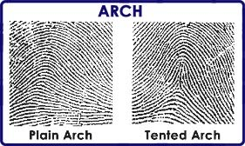 **Arch Loop**

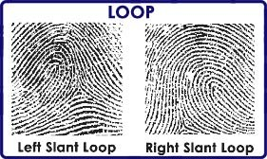

*Plain Arch Tented Arch R. Hand Ulnar Loop R. Hand Radial Loop*

**Whorl**

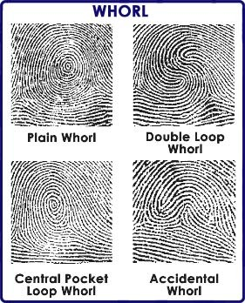 

*Plain Whorl Double Loop Whorl Central Pocket Whorl Accidental Whorl*

**Arch:** 5% population, ridge runs from one side to the other with no delta, plain angle is obtuse, tented angle is acute

**Loop:** 60-70% population, enters from one side and exits on the same side with one delta, radial enter and leave toward the thumb, ulnar enter and leave toward the pinky

**Whorl:** 25-35% population, 2 or more deltas, plain form complete circle and line between two deltas crosses whorl, double loop consists of two separate and distinct loops with two deltas each, central pocket forms complete circle and line between two deltas does not cross whorl, accidental consists of two different types of patterns having two or more deltas

**Fingerprint Analysis – Identification of Minutiae in a Set of Prints**

