*Jussim*

.1177/

5. System-Level Causes

Systems that value productivity in prestigious outlets

Systems that value novel, unexpected, important findings

Systems that value statistically significant findings/effects

Inadequate training in methods/stats/philosophy of science

Shortage of funding for research

1. Accuracy and Validity Motivations

Desire to publish accurate findings

Desire not to get caught publishing irreplicable results

3. Personal Motivations of Scientists

     Fame

     Employment, job security, tenure

     Promotions

     Paid well

     Respected by peer scientists

     Respected by non-scientists

     Achieve/support political goals

a

6. Perceptions of Practice Norms

suboptimal practices vs

optimal practices

d

e

b

4. Proximal Science-Specific Motivations

Desire to publish a lot in prestigious outlets

Get grants

Desire to produce novel, unexpected, important findings

Desire to confirm one's own past findings

Desire to confirm one's own theories

Desire to disconfirm competing theories or findings

f

2. Competencies

Statistical

Methodological

Philosophy of science

Logic

Theory

g

f

7. Potentially Suboptimal Research Practices

  Non-diagnostic study designs

  Studying small samples of participants

  Studying small samples of stimuli and settings

 P-hacking

  File-drawering

  Publishing findings before self-replicating

  Incomplete or inaccurate reports of research practices and decisions

  Non-systematic sampling of research participants

  Non-systematic sampling of research stimuli

  Misapplication/misinterpretation of statistical tools

  Other QRPs

 HARKing

 Confirmation biases in literature reviewing

  Confirmation biases in data handling

  Poorly specified theories

  Unfalsifiable hypotheses

Errors and biases in interpretations of results and literatures

i

11. Decreased social value ascribed to social and behavioral scientists

Decreased social value ascribed to social and behavioral science findings

Reduced funding for social and behavioral science research

Less student enrollment in social and behavioral science courses

Less faculty hiring in social and behavioral science departments

10. Failures of interventions to solve problems

9. Inaccurate Media Representation and Public Understanding of Scientific Results

l

j

k

8. Dissemination and Canonization of Erroneous Scientific Conclusions

Publication of inaccurate findings (e.g., false positives)

Over-claiming

Overgeneralizing

h****

Figure 1: Social Psychological Model of Scientific Practices

c

Figure 2: The Research Credibility Pyramid

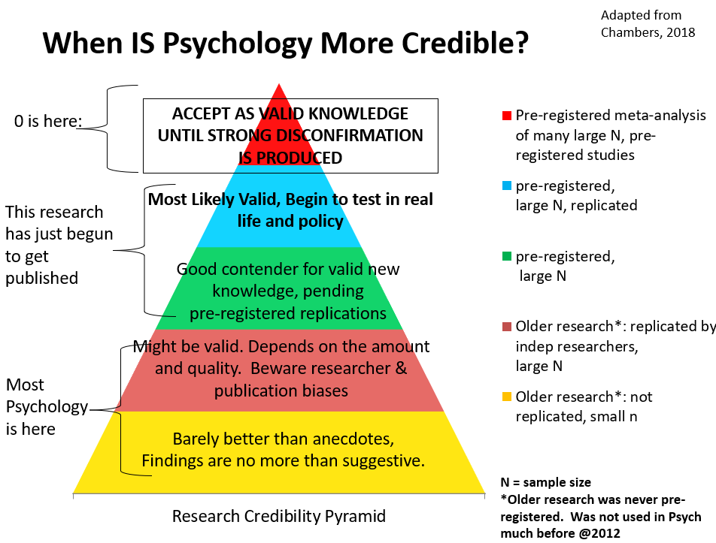

3. Personal Motivations of Scientists

dWhat is new here is the conceptual integration of ideas being widely discussed and practices being implemented, making explicit what is implicit in many people’s thinking.

eWhat is new here is the conceptual integration of ideas being widely discussed and practices being implemented, making explicit what is implicit in many people’s thinking.

5. System-Level Causes

m

1. Accuracy and Validity Motivations

4. Proximal Science-Specific Motivations

publications, grants, etc.

b

a

o

2. Competencies

6. Perceptions of Practice Norms

**Science Reform Innovations and Interventions**

**data posting**

**pre-registration**

**registered reports**

**badges**

**improved statistics**

**self-replication**

**larger sample sizes**

**more representative samples**

**stimulus sampling**

**checklists**

**adversarial collaborations**

n

c

h

f

f

g

p

7. Potentially Suboptimal Research Practices

Confirmation biases in literature reviewing and data handling

Other errors and biases in interpretations of results and literatures (logical errors,

myside biases, preferences biases, blind spots, misunderstanding of statistics)

Poorly specified theories

Unfalsifiable hypotheses

i

8. Dissemination and Canonization of Erroneous Scientific Conclusions

j

9. Inaccurate Media Representation and Public Understanding of Scientific Results

k

10. Failures of interventions to solve problems

l

11. Decreased social value ascribed to social and behavioral scientists

Figure 4: Social Psychological Model of Scientific Practices, with Reforms

Figure Captions

Figure 1: Social Psychological Model of Scientific Practices

Box 7 focuses on known problematic practices, but it should be obvious that, in each case, there is an opposite better practice (e.g., replace a nondiagnostic study design with a diagnostic one; replace small sample studies with large samples when possible).

Figure 4: SPSPM-R, SPSPM With Reforms

This model is identical to the Social Psychological Model of Scientific Practices, with the following exceptions: The examples under each box header are not shown; a central box for science reforms has been added (in bold), as have several paths indicating how those reforms are predicted to influence scientific practices; Box 7 (Potentially Suboptimal Practices) only shows practices that are ***not*** expected to be affected by these reforms – all others are not shown. The new box and paths are shown with bold text and thicker boxes and arrows. Although there are no compelling reasons to predict that the major proposed reforms will alter the remaining suboptimal practices that are shown in Box 7, path p is included to permit the possibility that they may do so for reasons that are not yet well-understood. This model makes clear that most current reforms target statistics, methods, and practices, but not problems of logic or interpretation, nor the downstream consequences of inaccurate scientific conclusions.

**Notes and Acknowledgements**

Address correspondence to Lee Jussim, [jussim@psych.rutgers.edu](mailto:jussim@psych.rutgers.edu).

This paper was based on work supported by grants from The Hewlett and Fetzer Foundations. It has greatly benefitted from discussions with Simine Vazire.