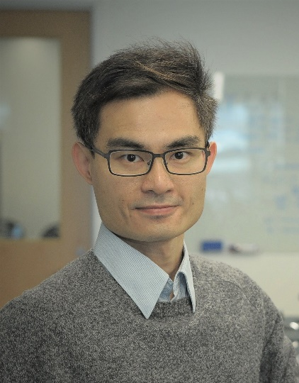
Dr. Ching-On Wong, a new assistant professor in the Department of Biological Sciences, has received an award from the National Institute on Aging for $156,000 for a project, titled Regulation of Apolipoprotein Secretion by TTYH1 And Tweety In Glial Cells. This project examines the APOE genotype, a major genetic risk factor for Alzheimer’s disease.
Lipid transport is integral to lipid metabolism and stress response in the central nervous system. Glial cells, such as astrocytes and microglia, use their endolysosomal and vesicular systems to process and secrete the lipid convoy called lipoproteins in the brain. However, our understanding of how glial lipoprotein processing couples to cellular stress and metabolism remains limited. This NIH-funded project investigates the regulation of apolipoprotein secretion by an evolutionarily conserved, yet uncharacterized, endolysosomal transmembrane protein. Our study will reveal the molecular pathway that coordinate oxidative stress response, lipid metabolism, and lipoprotein secretion in astrocytes.

