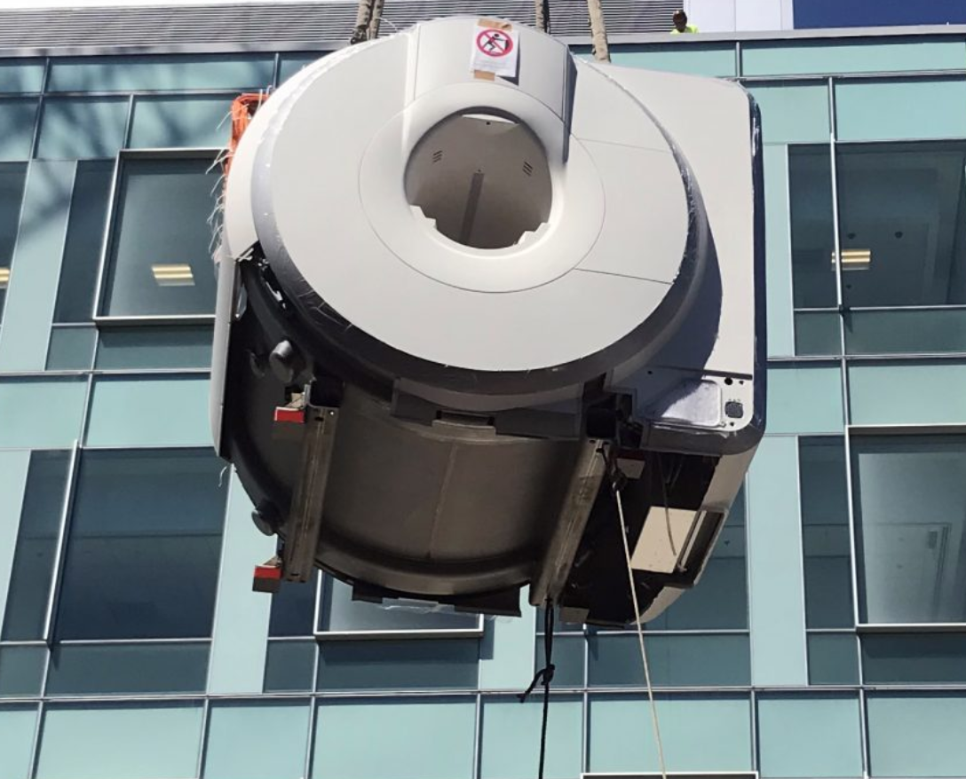

FY2020 ANNUAL REPORT
Office of Research & Sponsored Programs
July 1, 2019 - June 30, 2020
Index

Tables and Charts
Award data FY11 – FY20, by School…………………………………………………………….. 3
Award data FY19-20 ………………………………………………………………………………….. 4
Awards by School/Department FY19…………………………………………………… 4-5
Awards by School/Department FY20…………………………………………………… 4-5
Awards by source type, by School FY19………………………………………………..… 5
Awards by source type, by School FY20…………………………………………………. 5
Percentage of total RU-N awards by School, FY18 – FY20……………………… 6
Internal awards, by Department and source…………………………………………. 6

Proposal submission data FY19-20 ………………………………………………………….. 7
Submissions by School Department FY19………………………………………………. 7
Submissions by School Department FY20………………………………………………. 7
Submissions by source type, by School FY19………………………………………… 8
Submissions by source type, by School FY20………………………………………… 8
Percentage of total RU-N Submissions by School, FY18 – FY20……………. 8

Research Advisory Committee 2019 -2020…………………………………………………………… 10
Office of Research and Sponsored Programs……………………………………………………….…11

Previous page: The new Siemens PRISMA functional magnetic resonance imaging (fMRI) scanner arrived August 15,2020 and was installed three weeks later. It was funded by a $1.6 million grant from the National Science Foundation (NSF) with support from the Dean of SAS, the Chancellor, and the Office of Research and Economic Development.

 | FY11 | FY12 | FY13 | FY14 | FY15 | FY16 | FY17 | FY18 | FY19 | FY20
Arts and Sciences | 10,990,477 | 10,470,287 | 15,075,905 | 10,647,978 | 17,107,628 | 12,562,025 | 14,424,320 | 20,999,942 | 15,281,328 | 19,561,519
Business School | 7,821,312 | 5,545,105 | 7,815,486 | 9,848,476 | 5,862,114 | 5,383,565 | 7,018,806 | 6,625,645 | 10,174,520 | 12,447,587
Chancellor's Office | 2,220,651 | 1,681,959 | 1,100,694 | 378,525 | 1,418,466 | 4,738,992 | 4,823,659 | 4,235,607 | 8,408,843 | 5,015,016
CMBN | 4,850,600 | 3,102,971 | a.
Criminal Justice | 1,069,002 | 1,305,723 | 5,995,505 | 1,234,996 | 1,092,326 | 1,051,300 | 2,928,770 | 1,749,228 | 700,575 | 1,167,916
Nursing | 2,563,412 | 3,508,129 | 1,612,780 | 2,912,495 | b.
Law | 601,317 | 792,853 | 533,284 | 650,623 | 297,266 | 535,000 | 479,197 | 645,896 | 550,616 | 2,233,354
Graduate School | 181,469 |  | 42,000 | 90,000 | 635,775 | 663,996 | 626,225 | 626,225 | 921,181 | 626,225
SPAA | 697,760 | 816,548 | 936,556 | 947,716 | 134,200 | 215,438 | 42,200 | 104,100 | 57,500 | 162,064
Total RU-N | 30,996,000 | 27,223,575 | 33,112,210 | 26,710,808 | 26,547,775 | 25,150,316 | 30,343,177 | 33,913,429 | 36,094,563 | 41,213,681

Notes: a. CMBN was an independent center at Rutgers University–Newark until 9/1/2012, when it joined the School of Arts and Sciences
b. Nursing joined RBHS with the merger of UMDNJ 7/1/13
Award Data FY2019 - FY2020
FY19 – FY20 Awards | FY2019 | FY2020
SCHOOL NAME/ DEPARTMENT | TOTAL
Chancellor-Newark | 8,408,843 | 5,015,016
Chancellor-Newark | 3,174,149 | 342,142
Abbott Leadership Institute |  | 286,375
Academic Foundations Center | 801,113 | 518,834
Academic Programs and Services | 17,146
Center for Precollege Programs | 994,503 | 1,179,267
Cornwall Center for Metropolitan Studies | 875,000 | 1,375,978
Counseling Center | 246,188 | 789,569
Honors Living and Learning Community | 1,520,000 | 300,000
Institute for Data Science, Learning and Applications | 686,342 | Moved to RBS
Office of University Community Partnerships | 60,000 | 203,150
Paul Robeson Gallery | 34,402 | 19,701
School of Arts & Sciences - Newark | 15,281,328 | 19,561,519
Biological Sciences | 1,398,155 | 2,763,881
Center for Migration and the Global City | 13,500 | 35,000
Center for Molecular & Behavioral Neuroscience | 4,764,001 | 5,271,962
Chemistry | 1,155,052 | 1,804,008
Clement Price Institute | 285,000 | 67,200
Earth & Environmental Sciences | 3,743,220 | 1,343,342
Economics | 74,196 | 26,825
English |  | 1,518,685
History | 30,000 | 22,342
Humanities Action Lab |  | 50,000
Mathematics & Computer Science | 1,506,481 | 2,218,393
Physics |  | 942,975
Psychology | 1,830,440 | 3,047,935
Urban Education | 481,283 | 448,971
Rutgers Business School | 10,174,520 | 12,447,587
Center for Urban Entrepreneurship | 246,500 | 190,000
Dean's Office | 845,644 | 1,431,974
GSM - Small Business Development Center | 6,942,070 | 8,923,526
Institute for Ethical Leadership | 360,000 | 60,000
Management and Global Business | 172,094
SCHOOL NAME/ DEPARTMENT | FY2019 TOTAL | FY2020 TOTAL
Management Science & Computer Information Studies | 878,127 | 638,356
RAISED |  | 556,500
Rutgers Institute for Data Science, Learning, and Applications |  | 581,705
Supply Chain Management | 730,085 | 65,526
School of Criminal Justice | 700,575 | 1,167,916
Graduate School-Newark | 921,181 | 626,225
Law School-Newark | 550,616 | 2,233,354
School of Public Affairs & Administration | 57,500 | 162,064
Total | $36,094,563 | $41,213,681

FY2019 Awards by amount ($) and number (#)
By source and RU-N unit
RU-N unit | Federal |  | Foundation |  | New Jersey |  | Corporations |  | Total
 | $ | # | $ | # | $ | # | $ | # | $ | #
SASN | 12,481,831 | 56 | 2,066,757 | 36 | 558,892 | 7 | 173,848 | 2 | 15,281,328 | 101
RBS | 7,725,791 | 13 | 1,322,356 | 13 | 976,373 | 6 | 150,000 | 2 | 10,174,520 | 34
Chancellor | 1,762,981 | 9 | 5,520,916 | 28 | 1,104,946 | 6 | 20,000 | 1 | 8,408,843 | 44
SCJ | 249,410 | 1 | 89,970 | 2 | 361,195 | 2 | 0 | 0 | 700,575 | 5
Law | 184,000 | 2 | 223,025 | 4 | 143,591 | 1 | 0 | 0 | 550,616 | 7
Grad School | 626,255 | 1 | 294,956 | 1 | 0 | 0 | 0 | 0 | 921,181 | 2
SPAA | 0 | 0 | 45,000 | 3 | 12,500 | 1 | 0 | 0 | 57,500 | 4
Total | 23,030,268 | 82 | 9,562,980 | 87 | 3,157,497 | 23 | 343,848 | 5 | 36,094,563 | 163
RU-N funding by source | 64% | 42% | 26% | 44% | 9% | 12% | 1% | 3% | 100% | 100%
FY2020 Awards by Amount ($) and Number (#)
By source and RU-N unit

RU-N unit | Federal |  | Foundation |  | New Jersey |  | Corporations |  | Total
 | $ | # | $ | # | $ | # | $ | # | $ | #
SASN | 13,788,193 | 42 | 4,237,952 | 38 | 1,385,372 | 8 | 150,002 | 2 | 19,561,519 | 90
RBS | 9,622,708 | 7 | 1,652,648 | 4 | 325,526 | 3 | 265,000 | 2 | 11,865,882 | 16
Chancellor | 1,890,183 | 9 | 1,183,316 | 20 | 1,773,222 | 7 | 750,000 | 2 | 5,596,721 | 38
SCJ | 0 | 0 | 463,916 | 4 | 158,000 | 2 | 546,000 | 2 | 1,167,916 | 8
Law | 95,000 | 1 | 361,000 | 3 | 1,777,354 | 3 | 0 | 0 | 2,233,354 | 7
Grad School | 626,225 | 1 | 0 | 0 | 0 | 0 | 0 | 0 | 626,225 | 1
SPAA | 0 | 0 | 126,702 | 6 | 35,362 | 2 | 0 | 0 | 162,064 | 8
Total | 26,022,309 | 60 | 8,025,534 | 75 | 5,454,836 | 25 | 1,711,002 | 8 | 41,213,681 | 168
RU-N funding by source | 63% | 36% | 19% | 45% | 13% | 15% | 4% | 5% | 100% | 100%

Percentage of total RU-N awards by School, FY18 – FY20
 | FY18 |  | FY19 |  | FY 20 |  | % of Total FY17 - FY19
 | $ | % | $ | % | $
SASN | 20,999,942 | 60% | 15,281,328 | 60% | 19,561,519 | 47% | 50%
RBS | 6,625,645 | 19% | 10,174,520 | 19% | 11,865,882 | 29% | 26%
Chancellor | 4,235,607 | 12% | 8,408,843 | 12% | 5,596,721 | 14% | 16%
SCJ | 1,749,228 | 5% | 700,575 | 5% | 1,167,916 | 3% | 3%
Law | 645,896 | 2% | 550,616 | 2% | 2,233,354 | 5% | 3%
Graduate School | 626,225 | 2% | 921,181 | 2% | 626,225 | 2% | 2%
SPAA | 104,100 | 0% | 57,500 | 0% | 162,064 | 0% | 0%
Total | 34,986,643 | 100% | 36,094,563 | 100% | 41,213,681 | 100% | 100%

FY2020 Internal Awards

SCHOOL NAME/ DEPARTMENT | Amount | Number
School of Arts & Sciences - Newark | 431,283 | 23
Biological Sciences | 52,600 | 2
Center for Molecular & Behavioral Neuroscience | 162,700 | 4
Chemistry | 2,500 | 1
Economics | 76,000 | 5
English | 13,360 | 3
History | 450 | 1
Political Science | 13,968 | 3
Psychology | 91,800 | 2
Spanish & Portuguese Studies | 10,000 | 1
Urban Education | 7,905 | 1
Rutgers Business School | 33,607 | 3
Accounting, Business Ethics and Information Systems | 2,500 | 2
Supply Chain Management | 31,107 | 1
Law School-Newark | 133,750 | 4
School of Public Affairs & Administration | 50,000 | 1
Total | 648,640 | 31
Sources of Funding
Office of the Chancellor, Rutgers - Newark | 326,907 | 8
Office of Research and Economic Development | 215,110 | 16
Rutgers Global | 28,873 | 4
School of Law | 40,000 | 1
Center of Alcohol and Substance Use Studies | 20,000 | 1
Express Newark | 17,750 | 1

Proposal Submissions Data

FY19 – FY20 Submitted proposals | FY2019 | FY2020
SCHOOL NAME/ DEPARTMENT
Chancellor-Newark | 8,559,225 | 4,202,743
Chancellor-Newark | 1,209,600 | 265,745
Abbott Leadership Institute | 129,525 | 299,050
Academic Foundations Center | 305,912 | 265,802
Academic Programs and Services | 270,000
Center for Precollege Programs | 160,000 | 294,269
Cornwall Center for Metropolitan Studies | 930,204 | 1,325,275
Counselling Center |  | 789,569
Express Newark |  | 135,173
Honors Living and Learning Community | 5,269,650 | 300,000
Institute for Data Science, Learning and Applications | 658,753 | Moved to RBS
Office of University Community Partnerships | 264,663 | 393,458
Paul Robeson Art Gallery | 19,701 | 34,402
Student Affairs |  | 100,000
School of Arts & Sciences - Newark | 33,142,223 | 26,409,998
African American and African Studies |  | 15,184
Arts, Culture and Media | 243,000 | 99,974
Biological Sciences | 4,419,724 | 6,054,050
Center for Migration and the Global City | 13,500 | 60,000
Center for Molecular & Behavioral Neuroscience | 8,845,650 | 7,893,254
Chemistry | 2,940,586 | 3,000,070
Clement A. Price Institute on Ethnicity, Culture, and the Modern Experience | 288,642 | 90,000
Earth & Environmental Sciences | 4,605,760 | 1,529,416
Economics | 74,196
English |  | 768,684
History | 221,187 | 55,000
Humanities Action Lab | 177,380 | 362,096
Mathematics & Computer Science | 3,750,983 | 1,270,840
Physics | 270,793 | 136,819
Political Science |  | 29,767
Psychology | 6,467,934 | 4,282,130
Social Work |  | 191,353
Urban Education | 822,888 | 571,361
SCHOOL NAME/ DEPARTMENT | FY2019 TOTAL | FY2020 TOTAL
Rutgers Business School | 8,764,319 | 16,996,890
Center for Urban Entrepreneurship | 1,244,724 | 1,007,523
Dean's Office | 880,288 | 713,209
GSM-Small Business Development Center | 3,989,525 | 8,115,528
Institute for Data Science, Learning and Applications | Previously under Chancellor | 655,934
Institute for Ethical Leadership |  | 60,000
Management and Global Business | 123,001
Management Science & Computer Information Systems | 894,134 | 829,925
RAISED |  | 5,614,771
Supply Chain Management | 973,894 | 34,950
School of Criminal Justice | 576,842 | 2,761,762
Graduate School-Newark | 517,160 | 517,160
Law School-Newark | 319,016 | 1,044,504
School of Public Affairs & Administration | 95,000 | 542,127
Total Request | $52,040,953 | $52,475,184

FY 2019 Submitted Proposals by Request Amount ($) and Number (#)
By source and RU-N unit
 | $ |  | # |  | $ |  | # |  | $
SASN | 28,025,114 | 90 | 3,955,360 | 69 | 727,533 | 8 | 434,216 | 4 | 33,142,223 | 171
RBS | 5,895,829 | 18 | 1,647,020 | 13 | 1,046,470 | 7 | 175,000 | 3 | 8,764,319 | 41
Chancellor | 151,919 | 1 | 7,667,972 | 27 | 739,364 | 3 | 0 | 0 | 8,559,255 | 31
SCJ | 0 | 0 | 457,446 | 7 | 119,396 | 2 | 0 | 0 | 576,842 | 9
Law | 99,016 | 1 | 220,000 | 4 | 0 | 0 | 0 | 0 | 319,016 | 5
Grad School | 386,820 | 1 | 197,478 | 2 | 0 | 0 | 0 | 0 | 584,298 | 3
SPAA | 0 | 0 | 80,000 | 4 | 15000 | 1 | 0 | 0 | 95,000 | 5
Total | 34,558,698 | 111 | 14,225,276 | 126 | 2,647,763 | 21 | 609,216 | 7 | 52,040,953 | 265
RU-N funding by source | 66% | 42% | 27% | 48% | 5% | 8% | 1% | 3% | 100% | 100%
FY 2020 Submitted Proposals by Request Amount ($) and Number (#)
By source and RU-N unit
 | Federal |  | Foundation |  | New Jersey |  | Corporations |  | Total
 | $ | # | $ | # | $ | # | $ | # | $ | #
SASN | 20,666,262 | 78 | 4,401,206 | 60 | 926,530 | 8 | 416,000 | 4 | 26,409,998 | 150
RBS | 9,497,873 | 13 | 6,227,838 | 7 | 260,000 | 2 | 355,245 | 8 | 16,340,956 | 30
Chancellor | 1,191,477 | 6 | 1,703,229 | 21 | 1,538,971 | 5 | 425,000 | 2 | 4,858,677 | 34
SCJ | 393,764 | 3 | 1,980,788 | 12 | 81,210 | 2 | 306,000 | 2 | 2,761,762 | 19
Law | 100,000 | 1 | 213,420 | 3 | 731,084 | 2 | 0 | 0 | 1,044,504 | 6
Grad School | 517,160 | 2 | 0 | 0 | 0 | 0 | 0 | 0 | 517,160 | 2
SPAA | 83,469 | 2 | 423,296 | 12 | 35,362 | 2 | 0 | 0 | 542,127 | 16
Total | 32,450,005 | 105 | 14,949,777 | 115 | 3,573,157 | 21 | 1,502,245 | 16 | 52,475,184 | 257
RU-N funding by source | 62% | 41% | 28% | 45% | 7% | 8% | 3% | 6% | 100% | 100%

Percentage of total $ requested by School, FY18 – FY20
 | FY 18 |  | FY 19 |  | FY 20 |  | % of Total $ FY18 – FY20
 | $ | % | $ | % | $ | %
SASN | 32,387,093 | 69% | 33,142,223 | 64% | 26,409,998 | 50% | 61%
RBS | 5,885,758 | 13% | 8,764,319 | 17% | 16,340,956 | 31% | 20%
Chancellor | 6,045,379 | 13% | 8,559,255 | 16% | 4,858,677 | 9% | 13%
SCJ | 1,784,444 | 4% | 576,842 | 1% | 2,761,762 | 5% | 3%
Law | 439,677 | 1% | 319,016 | 1% | 1,044,504 | 2% | 1%
Graduate School | 56,498 | 0% | 584,298 | 1% | 517,160 | 1% | 1%
SPAA | 261,578 | 1% | 95,000 | 0% | 542,127 | 1% | 1%
Total | 46,860,428 | 100% | 52,040,953 | 100% | 52,475,184 | 100% | 100%

Research Advisory Committee, 2019 - 2020
Chair
Piotr Piotrowiak, Vice Chancellor for Research & Collaborations
and Professor, Chemistry, SAS-N

Paul Boxer, Professor, Psychology, SAS-N; Co-Director, Center on Youth Violence and Juvenile Justice
John Cantwell, Distinguished Professor of International Business, Management & Global Business, Rutgers Business School
Todd Clear, University Professor, School of Criminal Justice; former Provost, RU-N, 2014-16
Bonnie Fong, Physical Sciences Librarian and Head of Emerging Technologies, Dana Library
Wilma Friedman, Professor, Biological Sciences, SAS-N
Yuan Gao, Professor, Earth & Environmental Sciences, SAS-N
Bart Krekelberg, Associate Director and Associate Professor, Center for Molecular and Behavioral Neuroscience, SAS-N
Gregory Porumbescu, Assistant Professor; Director, International Programs; and Associate Director, Transparency and Governance Center (TGC), SPAA
Jaideep Vaidya, RBS Dean’s Research Professor of Computer Information Systems, Management Science & Information Systems, Rutgers Business School
Miklos Vasarhelyi, KPMG Distinguished Professor of Accounting Information Systems, Director of Rutgers Accounting Research Center, and Director, Continuous Auditing & Reporting Lab (CAR Lab), Rutgers Business School
Hui Xiong, RBS Dean’s Research Professor, Management Science & Information Systems, Rutgers Business School

The Rutgers University-Newark (RU-N) Office of Research and Sponsored Programs (ORSP) provides support to faculty, students, and staff from across RU-N who are working to secure external funding for their research projects and academic programs.
How Can We Help? RU-N ORSP’s staff members are available to meet with you to talk about your research and academic project interests and connect you to various resources designed to help you find funding and collaborative opportunities. We welcome researchers at all levels of expertise and look forward to talking with you about a specific proposal as well as exploring ideas and possibilities for support of your research, outreach, training, and other academic projects. Please contact us to arrange an individual meeting, a presentation, or a seminar for small groups.
Letitia Dean, Assistant Director deanle@rutgers.edu 973-353-1538
Patricia Bender, Research Contract/Grant Specialist pbender@rutgers.edu 973-353-1539
Tim Kirby, Research Contract/Grant Specialist timkirby@rutgers.edu 973-353-1540
Reuel Mebuin, Research Contract/Grant Specialist r.mebuin@rutgers.edu 973-353-3461
Lisa Condobery, Senior Administrative Assistant lisaj@newark.rutgers.edu 973-353-1537
Joe Broderick, Senior Grant Facilitator joe.broderick@rutgers.edu 973-353-1533
You may want to explore some on-line resources and databases available to all members of the RU-N community even before meeting with us. These include:
- Pivot contains information on over 25,000 funding opportunities for over $50 billion. These awards are available from federal, state, and foundation funding sources. In addition, personal profiles may be created which allow users to have a personal research profile.
- grants.gov lists federal grant funding opportunities (https://www.grants.gov/web/grants/search-grants.html)
- Foundation Directory Online (http://www.libraries.rutgers.edu/indexes/fconline) The Foundation Directory Online (Professional) provides information on more than 100,000 foundations, corporate giving programs, and grant making public charities in the US.
- GRADFUND (http://gradfund.rutgers.edu/index.php) provides valuable information and resources for graduate students as well as a database of grant opportunities.

Do you have questions about how to interpret institutional and sponsor policies and regulations? Please consult our website (http://researchoffice.newark.rutgers.edu/) or give us a call. We can help you find the policy and the policy professional best prepared to address your needs.

We look forward to working with you!

Piotr Piotrowiak, Vice Chancellor for Research & Collaborations, piotr@newark.rutgers.edu, 973-353-1537

Visit us at Blumenthal Hall, Suite 206, 249 University Avenue and https://researchoffice.newark.rutgers.edu/

