User Manual for Bonfire v2.0

Firestein Lab Sholl Analysis Software
v1.0 – 2010-05-05 by CGL and MKK

v2.0 – 2018-08-16 by KMO

1 Preface (PLEASE READ!): 2
2 File Structure: 3
3 Trace Neurons in NeuronJ: 4
3.1 Trace the cell body in NeuronJ and identify the trace as being “Type 06” 4
3.2 Trace the neurites in NeuronJ 4
3.3 Export trace files and trace identifier file from NeuronJ 5
4 Use Bonfire to build preliminary *.swc files from NeuronJ data: 8
4.1 Check that all parameters are set correctly in ‘bonfire_parameters’ 8
4.2 Reorganize folders using ‘bonfire_load’ 8
4.3 Create [Cell]_prelim.swc file using ‘bonfire_ndf2swc’ 10
5 Use NeuronStudio to finalize *.swc files: 11
5.1 Open and calibrate the neuron image in NeuronStudio 11
5.2 Use NeuronStudio to link neurites 11
5.3 Use ‘bonfire_trace_check’ to check *.swc files for errors 12
6 Use ‘bonfire’ to extract morphological data from *.swc files: 14
7 Use ‘bonfire_results’ to view the data: 16
8 Use ‘bonfire_export’ to export data to Excel: 17
8.1 Explanation of Excel files 17

Preface (PLEASE READ!):
This program is being released along with a manuscript describing the interpretation of the data (Langhammer et. Al (2010), “Multi-scale Sholl analysis of digitized neurons,” Cytometry: Part A). We urge you to read the manuscript in order to understand the nature and interpretation of the data available through the Bonfire program.

Working versions of the NeuronJ plugin for the ImageJ software from NIH, as well as NeuronStudio, must be installed in order to perform several of the image processing and neuron tracing steps. The three software packs can be downloaded from their respective websites:
- ImageJ - http://rsbweb.nih.gov/ij/
- NeuronJ - http://www.imagescience.org/meijering/software/neuronj/
- NeuronStudio - http://research.mssm.edu/cnic/tools-ns.html
- NOTE: NeuronStudio will not work on a Mac, but the other programs and MATLAB will.

For new users, we have included a small amount of sample data. All of the data has been traced and analyzed with the exception of a neuron named PRACTICE NEURON, found in the folder CONDITION 1. We suggest following along with the instructions the first time you use the program, while tracing PRACTICE NEURON.

The sample files used in the construction of this instruction manual, along with the Bonfire MATLAB code, have been included in a *.ZIP file with this manual.
- If you use a PC, we recommend using the version ‘2018-08-16 Bonfire PC’.
- If you use a Mac, we recommend using the version ‘2018-08-16 Bonfire Mac (xlwrite)’. The Sholl data are eventually exported as Excel files, but Mac is unable to use the built-in MATLAB function xlswrite. Therefore, this version uses a slightly different function to produce Excel files, called xlwrite.

Finally, this manual contains very detailed instructions for guiding you through each step of this semi-automated method for generating Sholl curves. Please read this guide carefully as most errors can be avoided by doing so. Should you encounter any errors, we suggest that you then consult the ‘Bonfire troubleshooting tips’ document, where we have documented several common errors and included solutions. If the guide does not offer a solution the error you encounter, feel free to reach out to Dr. Bonnie Firestein (firestein@biology.rutgers.edu), and she will connect you with the appropriate personnel to help you.

File Structure:
Bonfire’s ability to perform Sholl analysis on your data set depends on the files being organized in a specific structure. If the files are not organized in this fashion, the program will not run correctly. Follow the instructions below regarding the initial organization of your files.

Each experiment you run will likely contain several separate conditions, and you will take images of several cells in each condition. Your file structure should reflect this organization. You will have:

- A master folder (named [####-##-## EXPERIMENT] in Fig. 1, where the # are the date)
- Sub-folders (named [CONDITION 1], [CONDITION 2], [CONDITION 3] in Fig. 1)
- Cell Image files and NeuronJ files (named [Cell].tif and [Cell].ndf), contained in the [CONDITION #] folders
- A Bonfire folder (named [2018-08-16 Bonfire PC or Mac] in Fig. 1), also contained in the [####-##-## EXPERIMENT] folder

This layout is shown in Fig. 1 where the folder tree is shown at the left, and the contents of an example [CONDITION #] folder are shown in the right pane.

We generally recommend that you perform all analyses and other manipulations of data offline (i.e., copy your data to the desktop from any network drives before reorganizing rather than working on the network drives directly). Working in the local copy of your data will speed the process up, and prevent accidental loss or destruction of your data.
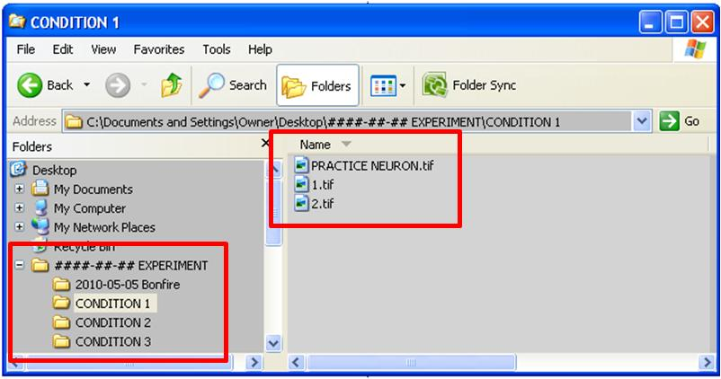
Figure 1 Initial file structure required for Bonfire analysis. The [Cell].tif files are the actual neuronal images, and are located in each [CONDITION #] folder. [CONDITION #] folders are located in the [###-##-## EXPERIMENT] Folder, along with the [2018-08-16 Bonfire] folder, containing the scripts required for Bonfire analysis.
Your file structure must match this (although the names of folders and files and the quantity of folders and files can be changed) or the program will not run correctly.

Trace Neurons in NeuronJ:
NeuronJ contains its own instructions for tracing neurons. What follows is a brief tutorial on tracing. See the NeuronJ instructions if you are confused about the basic use of NeuronJ.

Trace the cell body in NeuronJ and identify the trace as being “Type 06”
- Select the Add Traces button (Fig. 2 upper-left red box).
- Trace around the perimeter of the cell body.
- To label the trace as the cell body, press the “Label Tracings” button on the NeuronJ toolbar (shown in Fig. 2 in the upper-right red box). This will give you the “NeuronJ: Attributes” window, also shown in Fig. 2. Select your cell body trace with the cursor by clicking on it, and then select “Type 06” (Fig. 2 lower red box) in the NeuronJ: Attributes window and select OK.
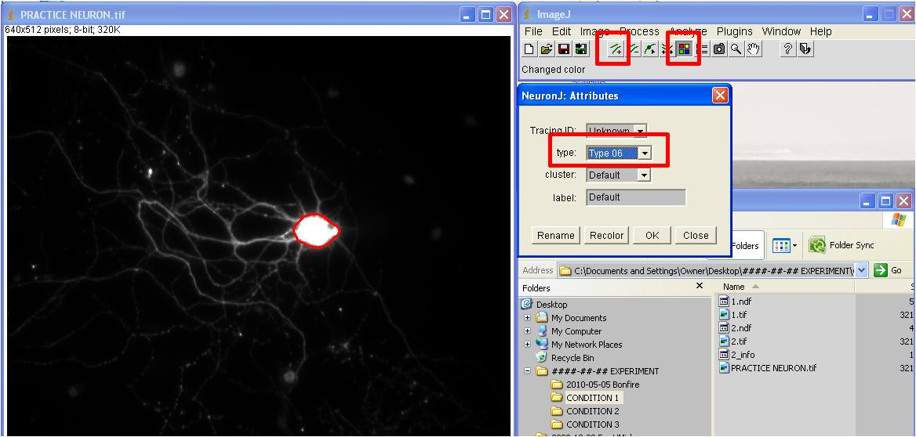
Figure 2 Identify and label the cell body. Add Trace, Label Trace, and Type Selection Menu are highlighted in red boxes.

Trace the neurites in NeuronJ
- Select the Add Traces button (Fig. 2 upper-left red box).
- Add a trace along each neurite branch.
- Neurite traces do not need to be labeled (as the cell body trace was)
- It is a suggested that the segments you draw stop at each branch point, with each daughter branch starting at that point as a new trace. This will help with the automatic branch linkage later in the program.
- Click the Save Tracings button and save the tracing you have created in the same folder as the image file. This will create the NeuronJ file corresponding to that cell image (and will by default name it with the same name as the cell image file, but with a *.ndf extension – see Fig. 3).
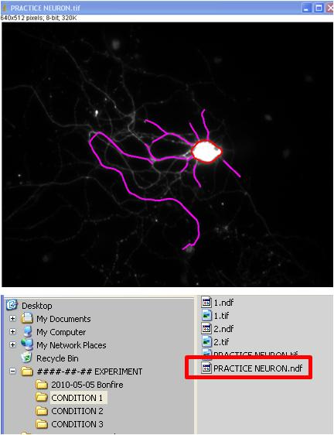
Figure 3 Trace neurites and save *.ndf file. All *.ndf files should be saved in the same condition folder with the same name as their original images.

Export trace files and trace identifier file from NeuronJ
Two types of files must be exported from NeuronJ, and saved into the appropriate [CONDITION #] folder along with the [Cell].tif and [Cell].ndf files, in order to provide the necessary data to Bonfire;
- Trace Files: These are *.txt files (also called text files), which contain the coordinates of the points defining each of the traces created and labeled earlier. They are named [Cell].[N#].txt. The first part, [Cell], refers to the [Cell].tif file that the trace belongs to. The second number, [N#], refers to the numerical identifier of the particular trace within the set of traces belonging to that cell.
- Trace Identifier File: This is a data file with no 3-letter file extenstion which contains data about which traces correspond to neurites and which corresponds to the cell body.

To export the files, perform the following:
- Select the Export Trace button (Fig. 4 upper red box). This will call up the NeuronJ: Export dialogue box.
- Select the second option, “Tab-deliminated text files: separate file for each tracing” (Fig. 4 lower red box)
- Allow NeuronJ to choose the name of the files (it will choose the same name as the original image), and the save location (it will choose the same location as the original image file).
- This will create a series of *.txt files (one for each trace) and save them in the [CONDITION #] folder with the original *.tif and *.ndf files.
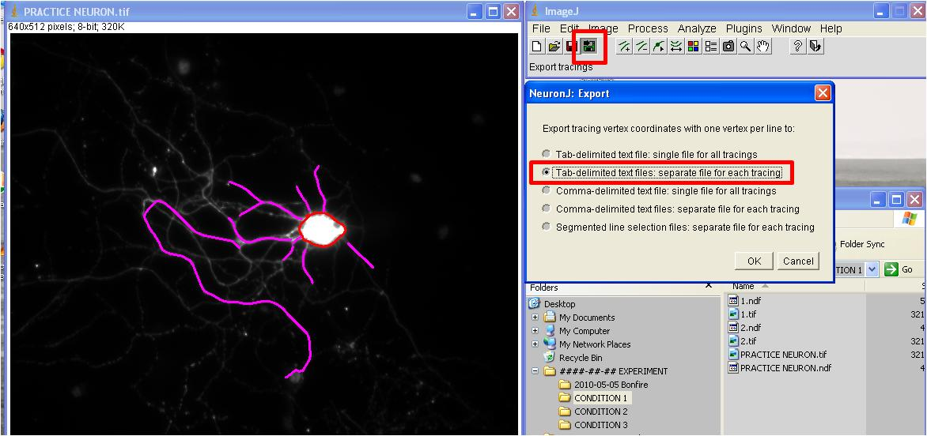
Figure 4 Export trace data files. Add Trace, Label Trace, and Type Selection Menu are highlighted in red boxes.
- Select the “Measure Tracings” button on the NeuronJ toolbar (shown in the upper red box in Fig. 5).
- This will open the “NeuronJ: Measurements” window. Select only the “Display tracing measurements” option (shown in the lower-right red box in Fig. 5), and press “Run.”
- In the “NeuronJ: Tracings” window (shown in the left-most red box in Fig. 5) select “File” and the “Save As…” option, and save the file as ‘[Cell]_info’
- NOTE: The file name must exactly match (including capitalization) the name of the image file it is tied to, and it should not contain a 3-letter file-extension. In our examples, this file is named ‘PRACTICE NEURON_info’ because the image file is named ‘PRACTICE NEURON.tif.’
- If your computer automatically appends the [Cell]_info file with a *.xls extension, this must be manually deleted, or later portions of the program will not run correctly.
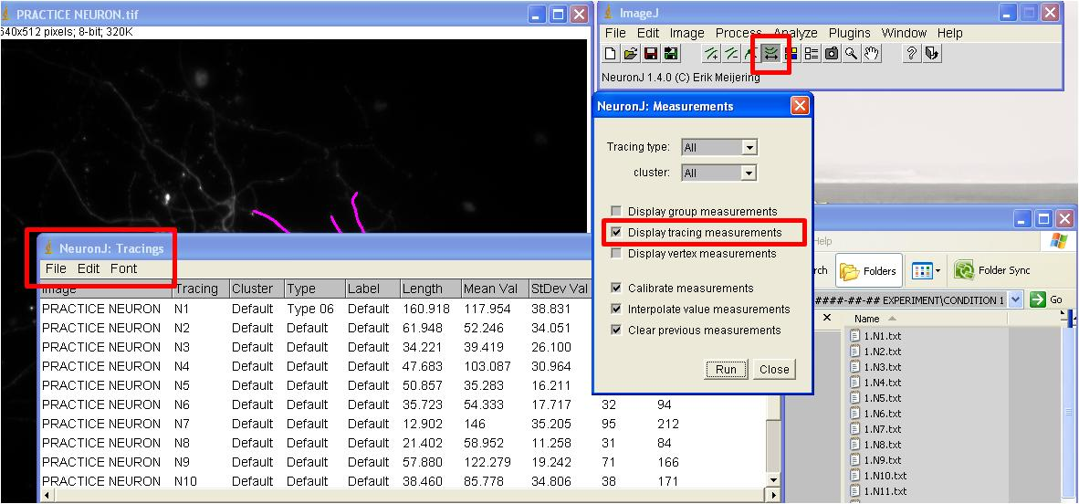
Figure 5 Export trace data files. Add Trace, Label Trace, and Type Selection Menu are highlighted in red boxes.
Once all the files have been successfully exported the final file-structure should look like it does in Fig. 6, below. For each of the original images in the [CONDITION #] folder, there are now the following files:
- 1 x [Cell].tif
- 1 x [Cell].ndf
- 1 x [Cell]_info
- (N+1) x [Cell].N#.txt where N = the number of neurite branches that were traced
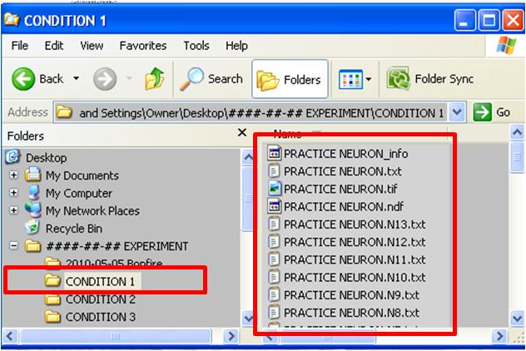
Figure 6 Final [CONDITION #] folder content following proper data export from NeuronJ.

Use Bonfire to build preliminary *.swc files from NeuronJ data:
Bonfire is a series of scripts executed in MATLAB. You must open the MATLAB command window, and execute programs from there (Do this by double clicking on the MATLAB icon). The basic MATLAB command window is shown in Fig. 7.

Check that all parameters are set correctly in ‘bonfire_parameters’
- Please note that the parameters for Sholl rings and pixel conversion are pre-set for a particular zoom setting on the Firestein lab’s microscope. You will almost certainly need to change these parameters to ensure that your analysis is performed correctly.
- To do so, open ‘bonfire_parameters.m’ in MATLAB.
- For changing pixel conversion: Please change the variable pix_conv to suit your needs. As you will see, our conversion is such that 1 μm = 1.5 pixels.
- For changing the Sholl ring parameters: You can also change parameters relating to the Sholl rings. Changing the variable starting_pt allows you to alter where the concentric Sholl rings begin in micrometers (μm) from the cell body. We recommend starting at 0 μm. If you change the variable increment, this will allow you to control the distance (in μm) between Sholl rings. We recommend using a 6 μm increment.
- Once you’ve made the appropriate changes, make sure to SAVE ‘bonfire_parameters.m’.

Reorganize folders using ‘bonfire_load’
Reorganizing the large number of files associated with each neuron will allow you to navigate the data more easily, and will allow other programs to collect data more rapidly. The ‘bonfire_load’ command automatically generates the file structure necessary to use Bonfire Sholl analysis and associated tools.

- Open MATLAB by double clicking on the icon
- Change the working directory (where MATLAB looks for scripts to execute) by clicking on the ‘[…]’ button in the upper right of the command window (indicated in Fig. 7 as the upper-right red box). This will open a “Browse for window” allowing you to select a new working directory
- Select the [##-##-## Bonfire] folder in your master [####-##-## EXPERIMENT] folder as the new working directory (shown as the lower red box in Fig. 7)
- All commands in MATLAB are entered as text in the command window (dashed red box)
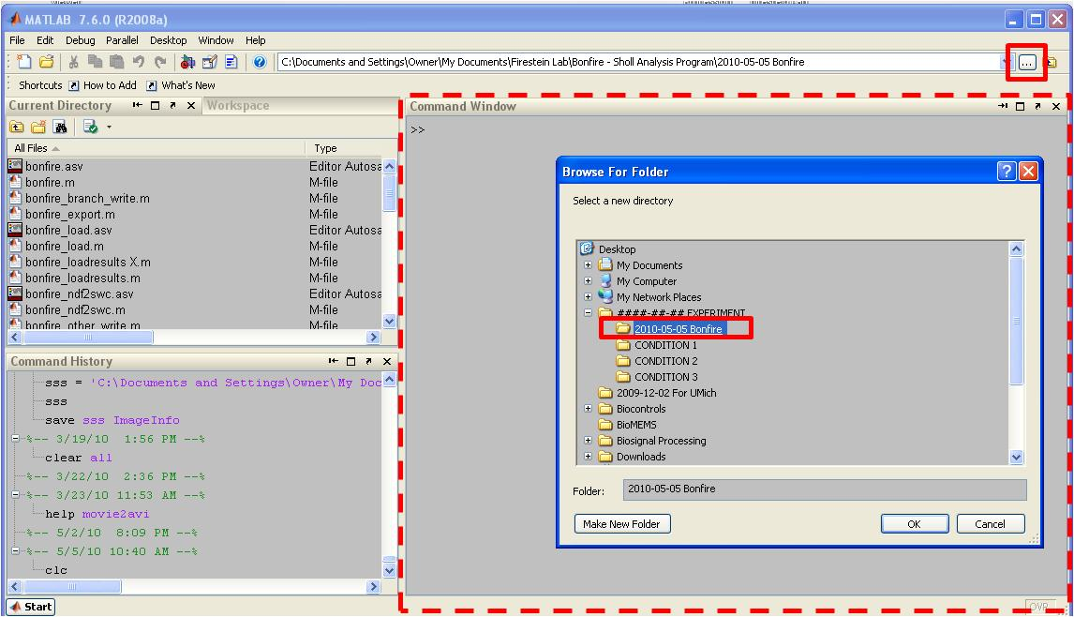
Figure 7 Change the working directory in MATLAB to the [####-##-## Bonfire] subfolder in your [###-##-## EXPERIMENT] folder.
- Type ‘bonfire_load’ into the command window (Fig. 8A upper-left red box). Press enter.
- In the folder selection window that opens, select the [CONDITION #] folder you wish to analyze (Fig. 8A right red box) and press OK.
- The program will automatically reorganize the data files in that folder.
- All the data files for each cell will be placed in its own folder (Fig. 8B, lower-right red box), giving you a new folder structure.
- The program will let you know if there were any common errors detected (Fig. 8B upper-left red box).
- Each [CONDITION #] subfolder now contains additional [Cell] sub-folders containing all the data for that individual cell. These [Cell] sub-folders each contain [Neurite Type] sub-folders, which contain the individual traces designated as that particular neurite type, as well as the [Cell].tif, [Cell].ndf, [Cell]_info trace identifier file.
- Note: If all files for a given cell are not named correctly, none will be relocated for that particular cell.
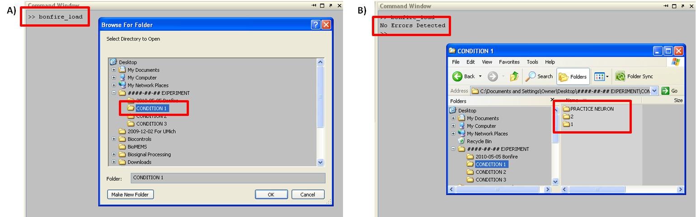
Figure 8 Run ‘bonfire_load’ to reorganize files into [Cell] folders.

Create [Cell]_prelim.swc file using ‘bonfire_ndf2swc’
- Once cell data files are successfully organized into their own folders, type ‘bonfire_ndf2swc’ into the command line and press the enter key. Again, you will need to select the [CONDITION #] folder you just reorganized with ‘bonfire_load’ (Fig. 9A).
- This will create a new file named [Cell]_prelim.swc in each [Cell] folder (Fig. 9B red box).
- The final file structure is shown in Fig. 9B. The master [####-##-## EXPERIMENT] folder still contains the [####-##-## Bonfire] and [CONDITION #] sub-folders. The [CONDITION #] folder now contains [Cell] folders with the conents shown in Fig. 9B.
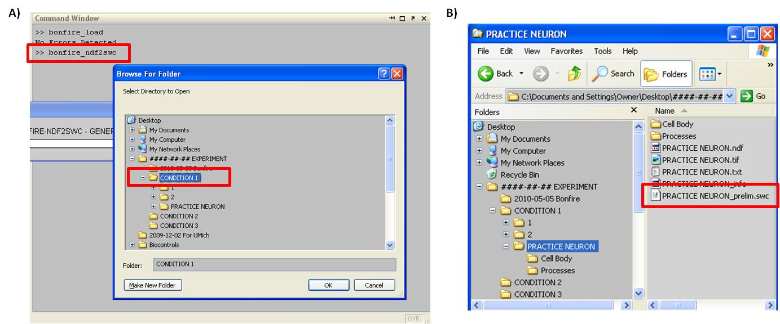
Figure 9 [Cell] folder contents following ‘bonfire_ndf2swc’ command.

Use NeuronStudio to finalize *.swc files:
NeuronJ allows for neurite location to be identified in Cartesian coordinates. However, the linkages between neurites need to be identified. For this purpose, use NeuronStudio. NeuronStudio displays the strings of nodes created when the trace was originally made using NeuronJ, and allows you to determine how they are connected.

Open and calibrate the neuron image in NeuronStudio
- Open the NeuronStudio program
- (Click File Open). Find the *.tif image of the neuron to edit and open it. The image file of the neuron should appear in the NeuronStudio work area.
- Select Run>Settings (Fig. 11 upper red box), and change the voxel size in all 3 directions from the default to a value of 1 (Fig. 11 lower red box). This will ensure proper scaling between NeuronJ data and NeuronStudio data. Failure to do so will result in misaligned nodes and image in NeuronStudio. (NOTE: Your data may require different values!)
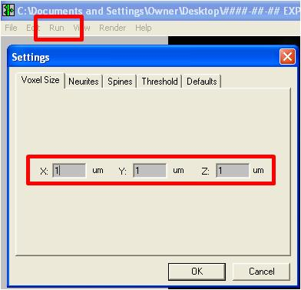
Figure 11 Calibrate the special scale of NeuronStudio.
- Click File Import SWC. The image file should now be overlaid with a trace image. The cell soma should be overlaid with a red circle. If it is not, try changing the voxel size values.

Use NeuronStudio to link neurites
Become acquainted with NeuronStudio’s features and shortcuts (they have an EXCELLENT online user manual, and knowing the keyboard shortcuts will save you a great deal of time). Our brief suggestions on how to use the program follow. (NOTE NeuronStudio is much easier to use and navigate with a mouse which has a scroll wheel.)

General use
- The toolbar is to the right of the workspace. It contains the various tools needed to work with and navigate NeuronStudio.
- To zoom, use the zoom tool (click to zoom in, Alt + click to zoom out) or the mouse scroll wheel.
- To move the image, use the hand tool.
- To select a node, use the neurite tool and Alt + click the node you would like to select. To select multiple nodes, Alt + click and drag a box around the nodes you would like to select and release the mouse button.
- To deselect nodes, use the exact same steps as above. All unselected nodes in the drag box created will stay unselected and all selected nodes will deselect.
- To clear all selections, press Esc.

Node notation
- A green node indicates that it is connected to adjacent nodes/the cell soma.
- Red nodes are not connected to adjacent nodes or are part of a trace that is not continuous with the cell soma.
- Purple nodes are endpoints.
- Yellow nodes are branch points.

Handling nodes
- To join unconnected nodes or unjoin connected nodes, select the two nodes and press J. Only two nodes can be joined/unjoined at a time.
- To create a node, click using the neurite tool without using the Alt key. This is difficult to do in NeuronStudio, so try to refrain from adding nodes/traces outside of NeuronJ.
- To delete nodes, select them and push Del.

Proper node linkage criteria
- Using the tools and features listed above, ensure that the following conditions are met:
- Each branch point (yellow nodes) can only create two branches.
- All traces must be continuous with the soma. In other words, there may only be 1 red node.

Exporting data
- Once you are certain that the neuron is adequately traced and has correct branch points and endpoints, save the *.swc file by clicking File Save Neurites Save. The name of the file should not need to be changed from the default name that NeuronStudio assigns it.
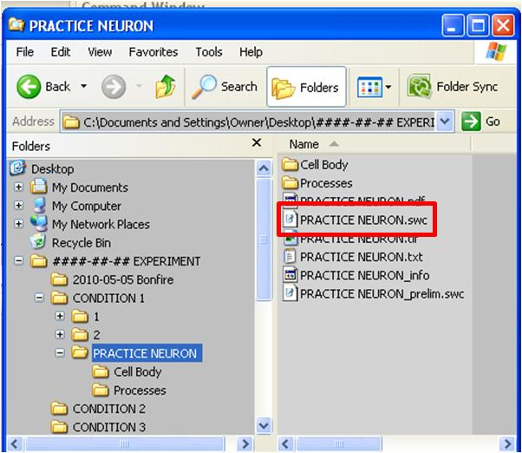
Figure 12 Correct [Cell] folder contents following file export from NeuronStudio.

Use ‘bonfire_trace_check’ to check *.swc files for errors
- Run ‘bonfire_trace_check’ on the [CONDITION #] folder that contains the images and traces just edited in NeuronStudio (Fig. 12A). This program checks if the conditions above were adequately met.
- Type ‘bonfire_trace_check’ into the command window and press the enter key.
- Select the [CONDITION #] folder containing the data you have processed with in previous steps.
- If everything has been linked correctly, ‘bonfire_trace_check’ will create a [Cell]_final.swc file (Fig. 12B), which is then used in future calculations by the program. This file fully describes the neurite patterning of your neuron.
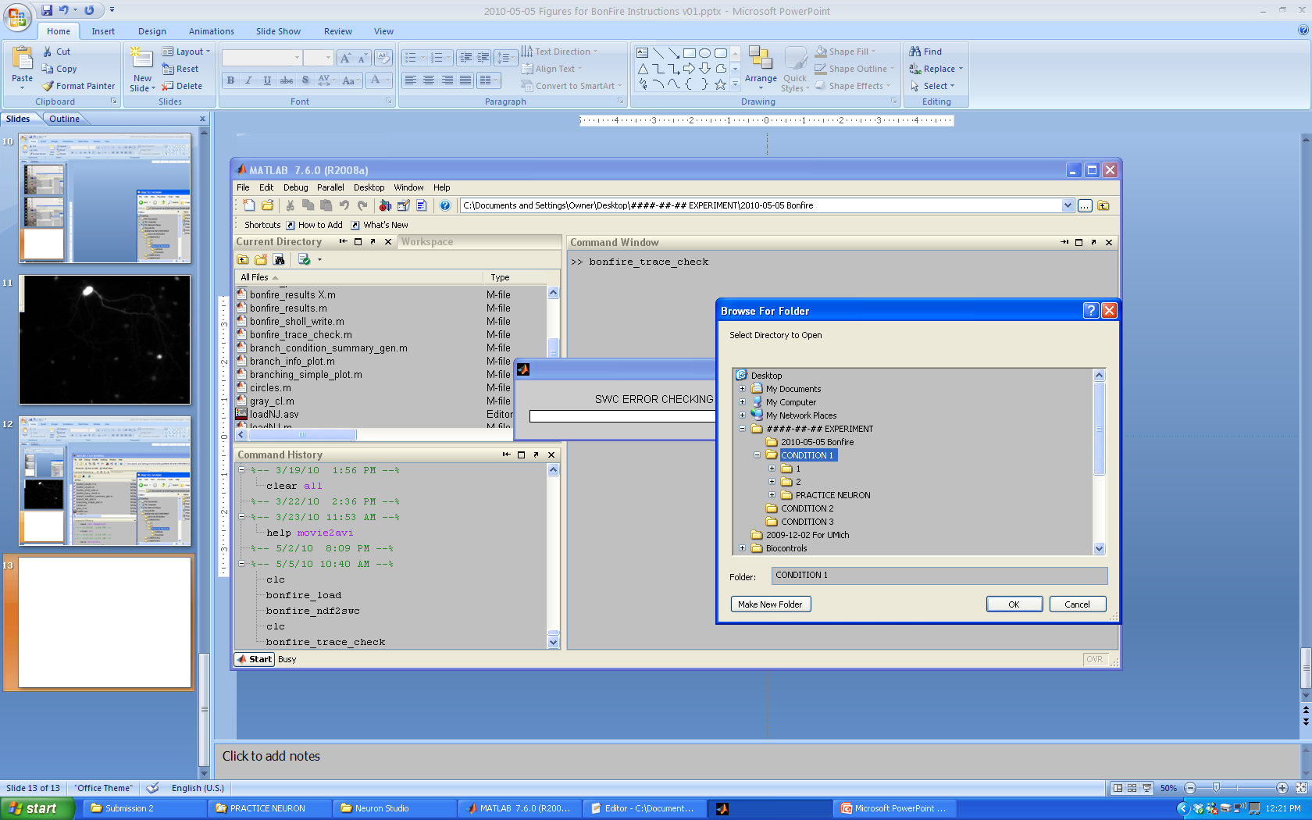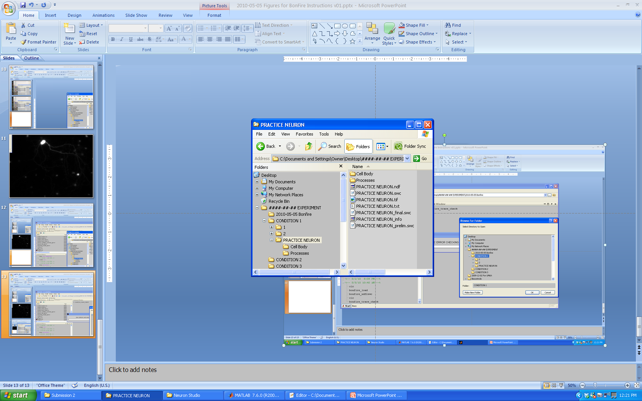
B)
A)
Figure 12 Correct [Cell] folder contents following ‘bonfire_trace_check.’
- If there are any errors in any of the images in the folder, the program will output images displaying where in the neuron trace the error occurred. These images may have a different naming system than the actual trace images, but correspond to the order of the trace images in the folder being checked, and may be inverted top-to-bottom. When displayed in MATLAB, they may also look different (i.e. be either flipped or rotated) compared to the pictures in NeuronStudio.
- Errors are usually one of the following: 1) a branch point with more than two branches (the branch point with the error will be denoted in the error-plot as a red dot), 2) an unjoined neurite (in which case the “soma” of that neurite is indicated as the error point).

Fixing Errors in NeuronStudio
- When fixing traces in NeuronStudio, open the image file and then the *.swc file you saved in the exporting data step above (do NOT open the [Cell]_prelim.swc file as this does not contain any of the linkages you made).
- Locate and fix the problem(s).
- Click File Save Neurites Save.
- Save the “fixed” *.swc file over the one you previously saved.
- Repeat for any images/traces that need to be fixed.
- Run ‘bonfire_trace_check’ again. If problems still exist, repeat this process until there are no more errors.

Use ‘bonfire’ to extract morphological data from *.swc files:
- Once you have used ‘bonfire_trace_check’ to make sure your neurites are correctly linked and to generate the [Cell]_final.swc files, use the ‘bonfire’ command to perform Sholl analysis on your digitized neuron files.
- Type ‘bonfire’ into the command window and press the enter key (Fig. 13 upper red box).
- Select the [CONDITION #] folder that contains the data you want to analyze and select OK (Fig. 13 lower red box).
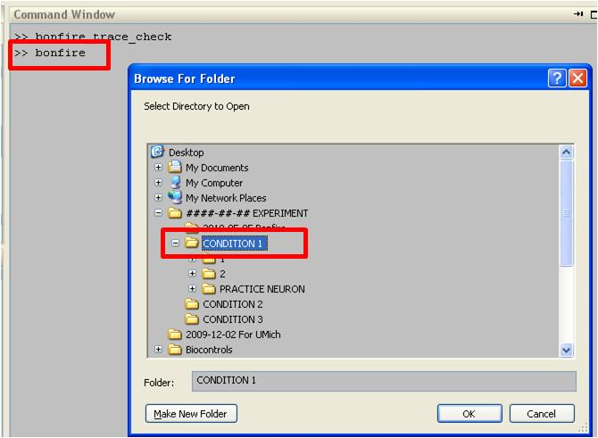
Figure 13 Run ‘bonfire’ on the [CONDITION #] folder containing data.
- The Bonfire analysis will generate a window for each of the neurons being analyzed, in which it graphs the neuronal morphology along with the Sholl rings used in the analysis (Fig. 14 left red box).
- NOTE: in Fig. 14, the soma appears as a large green dot because these windows are meant to be re-sized to fill the entire screen, at which point they are to scale.
- The ‘bonfire’ command will also generate the ‘cell_[Cell]_output.mat’ file (Fig. 14 right red box) that contains all the information on morphology taken from the Bonfire analysis.
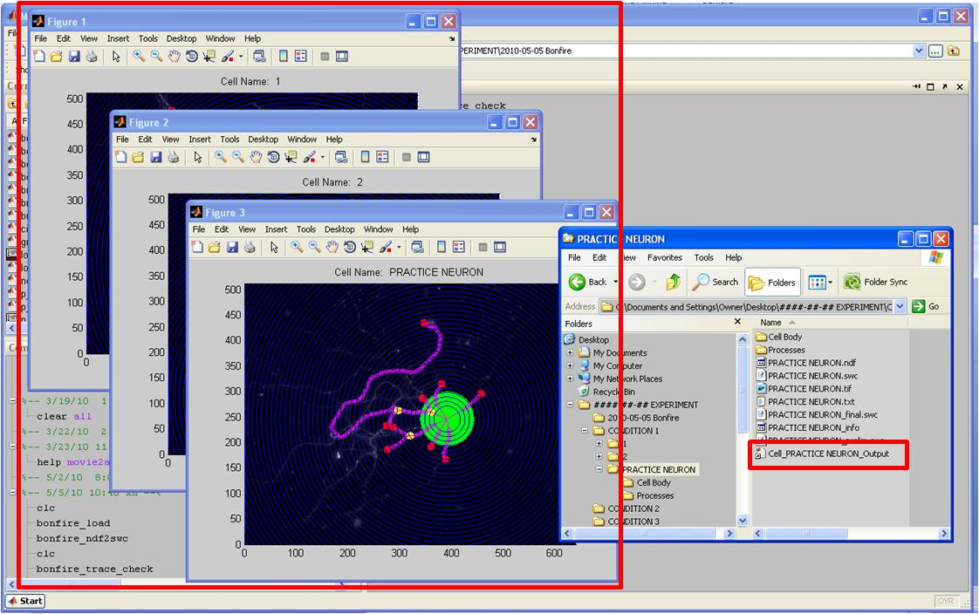
Figure 14 The ‘bonfire’ program returns quantitative data, and records it in an output .mat file.

Use ‘bonfire_results’ to view the data:
After ‘bonfire’ has run to completion, ‘bonfire_results’, can be used to provide a preliminary view of the data. However, this step is not necessary for completing the data analysis. The purpose is to provide a quick check of your data and to see if any of the conditions used in the experiment created noticeably different Scholl curves or branching numbers.
The program displays the total Sholl curve, as well as the process order-specific Sholl curves according to 3 different labeling schemes. Additionally, the program shows the average number and length of each process type as classified by each of the three labeling schemes. Multiple conditions can be selected for simultaneous viewing.

- Type ‘bonfire_results’ into the MATLAB command window. This will bring up a “Browse For Folder” window, allowing you to identify the conditions you would like included in your data visualization
- Conditions are identified one at a time
- You will select a condition by highlighting the [CONDITION #] folder and pressing enter (Fig. 15A)
- The folder selection window will close temporarily and re-open, allowing for the selection of additional conditions to be included (Fig. 15A)
- Repeat the above process indicating the [CONDITION #] folders you would like to compare
- When all [CONDITION #] folders have been selected, press ‘Cancel’ to exit the selection process
- ‘bonfire_results’ will return summary charts including the data from the [CONDITION #] folders you selected (Fig. 15B).
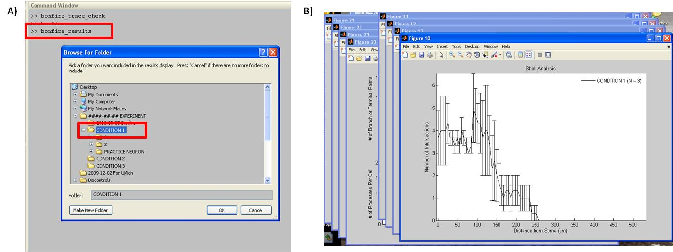
Figure 15 the ‘bonfire_results’ program can be used to generate preliminary plots of morphological data.

Use ‘bonfire_export’ to export data to Excel:
The Bonfire program also exports the data to Excel so it can be easily tabulated or passed to other programs for statistical testing.

- Type ‘bonfire_export’ into the command window (Fig. 16A red box).
- Select the [CONDITION #] folder containing the data you want to export.
- The program will create 4 excel files located in the [CONDITION #] folder you just selected with the names shown in Fig. 16B.
- These files contain the Sholl data, number of branches, length of branches, and number of branch and terminal points for each cell in the condition.
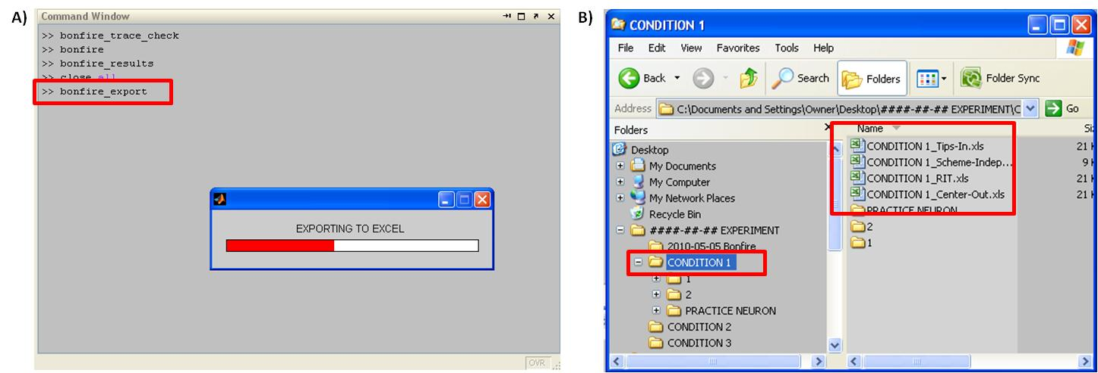
Figure 16 The ‘bonfire_export’ program creates Excel files containing all data for each cell.

Explanation of Excel files
The files created contain a number of different data types. A different file is created for each branch labeling scheme, plus one for branch independent metrics (i.e., number of branch points and terminal points). These spreadsheets contain the following information (Fig. 17):
- Fig. 17A: The number of branch points and terminal points per cell
- Fig. 17B: The number of Sholl intersections at each ring distance (µm) for each cell
- Fig. 17C: The number of branch segments of each order type for each cell
- Fig. 17D: The lengths (µm) of each of the segments in Fig. 17C.
- Fig. 17E: All of the data above examine on a whole-cell basis, or parsed for subsets of the arbor (i.e. only primary branches, or only secondary branches, or only tertiary branches).
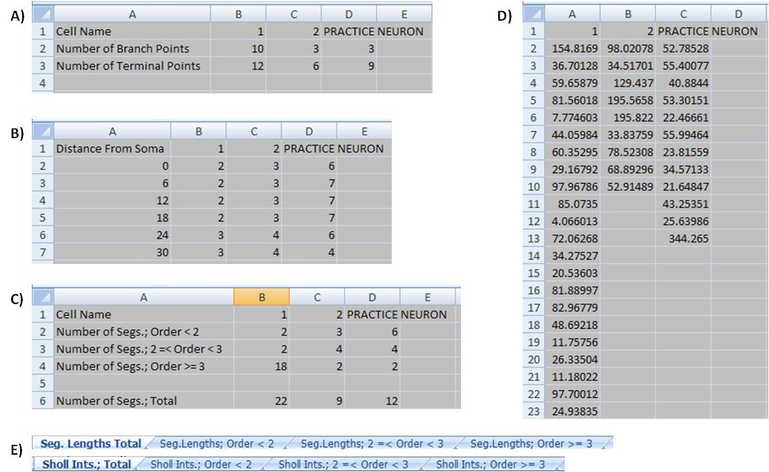
Figure 17 Data found in Excel spreadsheets.

