TROUBLESHOOTING TIPS FOR BONFIRE

Before using Bonfire, please note a few things:
1) The most recent updates include the ability to the MATLAB steps on a Mac.
2) If all else fails, try resaving or redoing the most recent step. Most of the times, the file just didn’t save correctly. Resaving will likely fix your issue.
3) We are pretty sure that FIJI does not save the files correctly. Please use ImageJ if possible.
4) MOST IMPORTANT! Troubleshooting is not as hard as you think. When an error occurs, look at the folder you are analyzing and figure out which image file is the “problem child” that caused the program to stop working. Think logically about what step didn’t work and go from there.

NOTES ABOUT SHOLL RING STARTING POINT AND PIXEL CONVERSION
- Starting point for Sholl circles:
  - Our default distance to start the Sholl rings is at 0 μm with 6 μm between each ring. This gives you data at 0 μm, 6 μm, 12 μm, etc…
  - If you want to start at a different distance, change the variable starting_pt (which will be in μm) in bonfire_parameters.m.
  - If you want different distances between Sholl rings, change the variable increment (which will be in μm) in bonfire_parameters.m.
- Pixel conversion:
  - The Olympus microscope and the EVOS microscope have different pixel conversions for the 20x objective. You MUST check bonfire_parameters.m before beginning tracing to make sure the variables are set correctly.
  - For 20x images on the Olympus: Open bonfire_parameters.m and make sure it says pix_conv = 1/(1.5);
  - For 20x images on the EVOS: Open bonfire_parameters.m and make sure it says pix_conv = 300/838.344;

Errors in bonfire_load
- Make sure that your image is saved as “whatever.tif” and not “whatever.TIF”. If the image extension is capitalized, MATLAB will say there is an error in the experimental folders and that the data may not have been exported correctly.
- Make sure that the FILENAME_info does not have a *.xls extension. You will get an error about a missing *.tif, *.ndf, or _info file if it does.
- If you get an error saying the cell_body is missing, go back to NeuronJ and check that you made the cell body trace (usually N1) as Type 06.
- Sometimes you will get a warning about “unidentified files”. This is due to hidden files for the thumbnails previously in that folder.
WARNING...UNIDENTIFIED FILE LABELED "Thumbs.db" IN EXPERIMENTAL FOLDERS. …
  - Sometimes these files have weird names, like ._DS Store or Thumbs.db, or something like that. This usually happens when you use NeuronJ on a Mac and then do the Bonfire steps on a PC. Delete the files if you can see them; if you can’t, move on to the next step.
  - It could also be traces that you made and then deleted. Say you are tracing the 4th dendrite (N4). If you delete that, NeuronJ will not call the new one N4; it will call it N5. If this happens, either delete the old files or move on to the next step and ignore them.
- If you get the following error, the file name of your picture is too long. Change it to something shorter and resave everything.
>> bonfire_load
??? Error using ==> char
Cell elements must be character arrays.

Error in ==> strvcat at 29
s = char(varargin{notempty});

Error in ==> bonfire_load at 45
types = strvcat(B(:,4));
- If you get the following error, just rerun bonfire_load. You may have to rerun it a few times to successfully complete this step.
>> bonfire_load
Error using movefile
No matching files were found.

Error in bonfire_load (line 67)
movefile([directory_root,'\',cell_list{ii},'.txt'],[directory_root,'\',cell_list{ii},'\',cell_list{ii},'.txt']);
Errors in bonfire_load (cont’d)

- If you get the following error in bonfire_load, you should try resaving your *.ndf, *.txt, and _info files in NeuronJ. Something probably went wrong with saving.
>> bonfire_load
Struct contents reference from a non-struct array object.

Error in getfield (line 36)
f = s.(deblank(strField)); % deblank field name

Error in bonfire_load (line 49)
B = getfield(S,'textdata');

- SOLUTION 1: If the above solution doesn’t work, you should check the _info file. It may be saving as a CSV file instead of an Excel file. Do the following:
- 1) Open the _info in Excel. When the program prompts you asking if you are sure you want to open, click yes.
- 2) See what the file looks like.

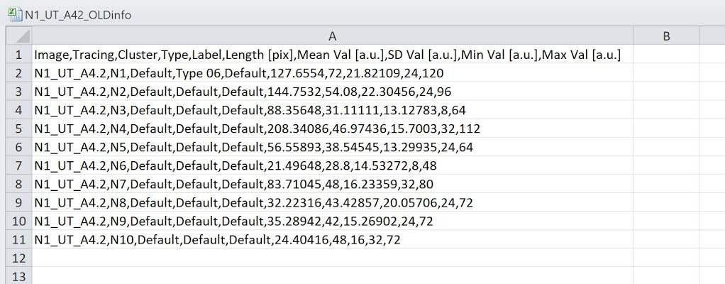
Fig 1. If your _info file looks like this in Excel– with commas (,) between each value – and everything is in one column, then you have a CSV file.
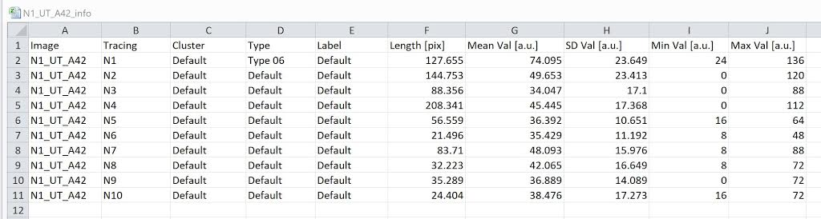
Fig 2. This is what you want your file to look like, where all of the columns are separate.

If you have a _info file that looks like Fig. 1, you can get a file that looks like Fig. 2 by doing the following:
- 3) Close Excel.
- 4) Go to your file and put a ".csv" extension at the end of the _info file.
- 5) Open this file in Excel (this should be the default option) to check that now everything is in separate columns. If so, then save this file as _info.xls. This should convert it to an Excel file.
- 6) Close Excel.
- 7) Now remove the *.xls extension like the instruction manual says, and the _info file should work in MATLAB.
- 8) FINAL NOTE: You will also need to delete the _info.csv file.

Errors in bonfire_load (cont’d)

- SOLUTION 2: If you are not having a CSV file issue, it could be an encoding issue. Do the following to determine if this is the case:
- 1) Open a blank Excel sheet. Under the “Data” tab, go to “Import from Text” (this navigation will be slightly different in different versions of Excel).
- 2) Import the _info file, and see what the file looks like.

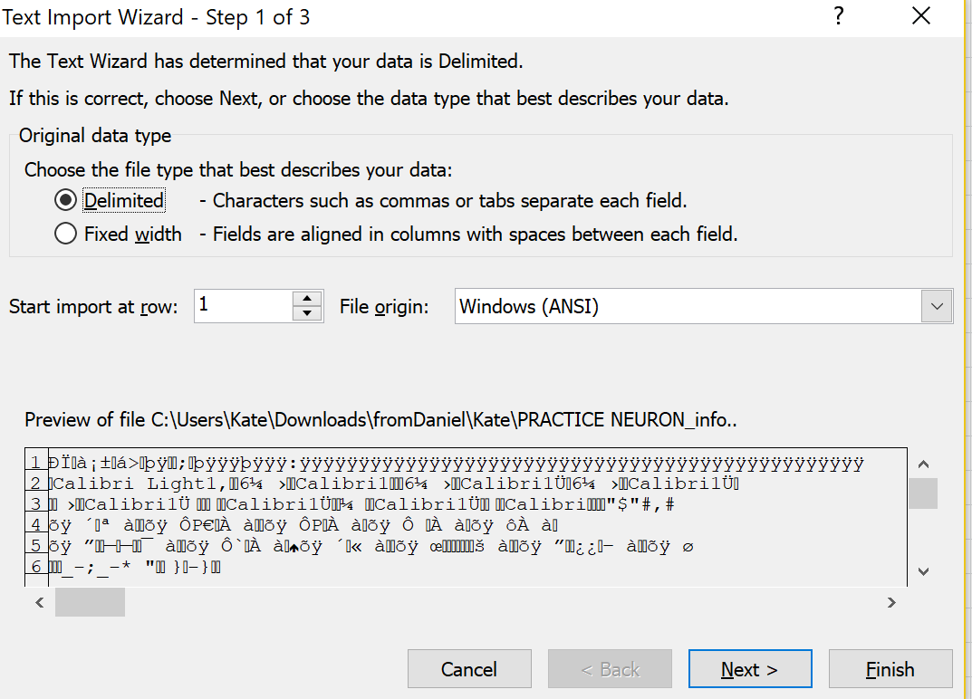
Fig 3. If your _info file looks like this during the import procedure into Excel, then you have an encoding issue. Your file is encoded in such a way that MATLAB cannot read it.
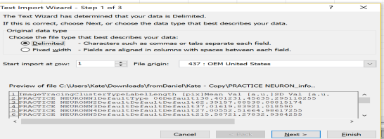
Fig 4. This is what you want your file to look like during the import procedure – everything is readable.

If you have a _info file that looks like Fig. 3, you can get a file that looks like Fig. 4 by doing the following:
- 3) Close Excel.
- 4) Open the _info in Excel. When the program prompts you asking if you are sure you want to open, click yes.
- 5) Save the file as a *.txt file (Text (Tab delimited file)). When Excel asks if you’re sure you want to save it that way, say yes.
- 6) Close Excel.
- 7) Now remove the *.txt extension, and the _info file should work in MATLAB. You can check the file by doing the data import step (Steps 1-2)
- 8) FINAL NOTE: You may also need to delete the old _info file.

Errors in bonfire_ndf2swc
- You need to run this for all images in the condition (not an individual neuron folder) because the program will not know where to look.
- If you get the following error, open up the *.tif file and the *.ndf file in NeuronJ and do all three saving steps (save, export, and measure).
>> bonfire_ndf2swc
Error using dlmread (line 143)
Mismatch between file and format string.
Trouble reading ‘Numeric’ field from file (row number 1, field number 1) ==>

Error in loadNJ (line 35)
IN = dlmread(strcat(directoryname,’\’,names(ii,:)));

Error in bonfire_ndf2swc (line 37)
[cell_bodyX, cellbodyY] = loadNJ([directory_root, ’\’, cell_list{ii}, ’\’], ’Cell Body’);
- If you get the following error, then something went wrong in bonfire_load step. If re-running bonfire_load doesn’t fix the error below, then you need to put all the files associated with the problem image back into the master folder and then rerun bonfire_load.
>> bonfire_ndf2swc
??? Index exceeds matrix dimensions.

Error in ==> bonfire_ndf2swc at 41
x0 = mean(cell_bodyX(1:max(find(cell_bodyX(:,1))),1));
- If you get the following error, you have one very long trace or you have traced too many segments. Open loadNJ.m and change lines 29 and 30. Line 29 defines the variable coordinatesX, and Line 30 defines the variable coordinatesY. If both are a matrix of 300x300 zeroes, change it to be 500x500 zeroes.
>> bonfire_ndf2swc
Subscripted assignment dimension mismatch.

Error in loadNJ (line 46)
coordinatesX(:,ii) = X;

Error in bonfire_ndf2swc (line 38)
[ProcessesX , ProcessesY] = loadNJ([directory_root,'\',cell_list{ii},'\'],'Processes');
  - Other possibility – this makes no sense, but the problem may be that the folders are organized wrong. Remember that all the *.txt, *.tif, *.ndf, etc. for every neuron have to be in one folder.

Errors in bonfire_trace_check
- If you get an error saying that it couldn’t import the data, check all of your folders. You may be missing one of the *.swc files . Go back and check all of your folders. Computers like to start with 11, 12, … 1, 21, 22, 23, … etc.
- If you get an error saying the following, you forgot to save the *.swc file. You will find that one of the folders only has *_prelim.swc.
>> bonfire_trace_check
Error using importdata (line 136)
Unable to open file.

Error in bonfire_trace_check (line 46)
SWC_struct =importdata([directory_root,'\',cell_list{ii},'\',
cell_list{ii},'.swc'],' ',15);

Errors in bonfire
- If during this step, you don’t get the Sholl curves overlaid over your images, you may have a problem. You won’t know until you get to the bonfire_export step and can look at the Excel file, but you may have to go back to NeuronJ and resave everything before proceeding. You will know you have a problem if the Sholl curves don’t look right (i.e. look zoomed in).
- If you get the following error, you need to go back to your pictures in NeuronStudio.
>> bonfire
Subscripted assignment dimension mismatch.

Error in swc_pgen (line 102)
p_SWC(qq,:) = [ind B_T P order_1 order_2 order_3 order_4
Length t_degree path_length];

Error in bonfire (line 65)
[SWC, p_SWC] = swc_pgen(SWC);
You have created a branch with 3 branchpoints. The bonfire step in MATLAB will not allow this even though NeuronStudio and the bonfire_trace_check step do. Delete all of the CELL_final.swc files. Now run bonfire_trace_check again. If any pictures pop up in MATLAB – they will have a black background, blue nodes, and a red dot where there is an error – you need to do the following steps for that picture: 1) delete the CELL_final.swc file, 2) open the CELL.swc file in NeuronStudio, 3) fix the error, 4) save the CELL.swc file, and 5) run bonfire_trace_check again. You should not get any errors, and you should be able to proceed with the rest of the steps. You still need to rerun bonfire_results and bonfire.
NOTE: If you need to fix a picture in NeuronStudio after running bonfire_trace_check, the pictures in MATLAB are UPSIDE DOWN compared to the pictures in NeuronStudio.

